What is the effect of crowd support on team performance?

**Using the Covid-19 pandemic to analyze the influence of crowd support on team performance**



1. Rijnders (**2063482**)

04-06-2021

MSc Marketing Analytics

Tilburg School of Economics and Management

Tilburg University

Master Thesis Supervisors:

1. van der Plas MSc

Dr. A.I.J.G. van Lin (co-reader)

Management Summary

The notion of home advantage in relation to team performance is a widely studied concept in sports-related academic literature. Studies such as those conducted by Schwartz and Barsky (1977) and Pollard (1986) document consistent better performance by teams playing at home compared to away teams. Crowd support is considered to be one of the major drivers of team performance and the resulting home advantage in sports. However, the effect of crowd support on home advantage and team performance is difficult to directly assess. During the Covid-19 pandemic, all soccer matches in major European soccer leagues had to be played without fans. We used this extraordinary situation to directly gauge the impact of crowd support on team performance.

To give managers an insight on how they could impact the performance of their team, we extended the analysis to the several moderating variables, namely the average age of players, the share of playing time for foreign players in the squad, the absolute crowd size and the stadium occupancy rate. Furthermore, we assessed to what extent the influence of crowd support on team performance is mediated by a referee bias in favor of home teams. We used a structural equation model(SEM) to to assess the influence of crowd support on team performance. We incorporated a latent construct referee bias that comprised of differences in fouls and yellow cards between home and away teams. In goal difference and points difference we used two separate measures of team performance as dependent variables.

We found that crowd support significantly affects team performance for both home and away teams. Part of this effect is mediated by a referee bias in favor of the home team. Furthermore, we found evidence that, rather than absolute crowd size, the stadium occupancy rate plays a major role in the size of the effect of crowd support on team performance. Teams with higher occupancy levels suffered more from the absence of crowd support than teams with low occupancy levels. Furthermore, we found no evidence for a significant influence of team age and share of playing time for foreigners on the relationship between crowd support and team performance.

Based on these findings, marketing managers know that the importance of a filled stadium lies beyond the extra revenue associated. Higher occupancy levels can mean the few extra points that bridge the difference between qualifying for European club competitions or not, or the difference between staying up in the highest division or relegating. Both outcomes have immense financial consequences. Additionally, decisions such as moving to a new stadium should be taken with utmost caution since moving to a bigger stadium could decrease the occupancy rate substantially.

Preface

In front of you lies the thesis “*What are the effects of crowd support on team performance and home advantage”*, which aims to understand the influence of crowd support on team performance and referee decision making. This thesis was written as the final step of completing the master program

Marketing Analytics at Tilburg University, Tilburg School of Economics and Management. The

process of writing this thesis has engaged me from February 2021 to June 2021.

This thesis was written under supervision of Joep van der Plas, who introduced me to this

topic. The process of writing this thesis has been challenging. Fortunately, Joep van der Plas

was always very helpful during our meetings. He provided excellent feedback to help me through the process of writing this thesis.

I would like to thank Joep van der Plas for the excellent guidance. I also would like to thank my parents, friends, and family for their support and encouraging words. This thesis will not be my final chapter at Tilburg University, as I am looking forward towards my participation in the QTEM program, for which I am very thankful to Tilburg University to be given this opportunity. I hope you enjoy reading my master thesis.

Alan Rijnders

Tilburg, June 4th, 2021

Table of contents

1 Introduction 5

2. Theoretical Background 9

2.1 Crowd support and home advantage 10

2.2 Moderating variables 11

2.3 The mediating role of referee bias 13

2.4 Hypotheses 14

3. Data and Methodology 17

3.1 Data collection 17

3.2 Variable Operationalization 18

3.3 Descriptive statistics 20

3.4 Home advantage with and without crowd support 20

3.5 Model 26

4. Analysis and Findings 27

4.1 Assumptions 27

4.2 Results overview 28

4.3 Robustness check 31

4.4 Moderating effect occupancy 32

5. Conclusion and Discussion 33

5.1 Conclusions 33

5.2 Managerial implications 35

5.3 Limitations and areas for future research 36

6. Bibliography 38

7. Appendix 44

# Introduction

Soccer is the most popular sport in the world with 265 million active soccer players around the globe (FIFA, 2007). In other words, roughly 4 percent of the total world population regularly plays soccer. The amount of fans is even more staggering, with 3.5 billion people tuning in for the FIFA World Cup Final between France and Croatia in 2018 (FIFA, 2019). Many of these fans were left without their favorite pastime when the Covid-19 pandemic struck Europe and other parts of the world in March 2020. After a few months of lockdown, the Bundesliga was the first major league to restart on the 16th of May 2020. Other major European leagues such as the Premier League, Serie A, and La Liga followed swiftly. Global social distancing measures during the Covid-19 pandemic introduced the phenomenon “Ghost Matches”; Soccer matches without any spectators attending. Some surprising results in favor of away teams in the first few weeks following the restart renewed interest in the role of crowd support and team performance.

Analyzing team performance in soccer can be quite complicated since home team performance and away team performance are interrelated. Therefore, it is necessary to consider home team performance relative to away team performance or vice versa. Home advantage is a frequently used concept for analyzing team performance in soccer as it incorporates both home and away team performance. Therefore we use the terms team performance and home advantage to refer to home team performance relative to away team performance throughout this thesis.

One would rationally assume that on average, home and away teams should collect an equal amount of points and score an equal amount of goals. However, Goumas (2014) shows that home teams on average win more games, collect more points, and score more goals than away teams. The author’s findings resonate with results from earlier studies such as those conducted by Clarke and Norman (1995) and Pollard (2006). Both studies reported a continual advantage across countries and time for teams playing at home. Apparently, through some mechanism, home teams perform better than away teams. Identification of the elements that enable home advantage to materialize provides valuable insights into the factors that drive team performance.

The exact source of the discrepancy in performance between home and away teams that creates home advantage is widely studied. Crowd support is often mentioned but its exact role has not yet been unambiguously defined. Pollard & Polla[rd (2005](https://shapeamerica.tandfonline.com/doi/full/10.1080/02640410601038576?scroll=top&needAccess=true)) for example, disprove the role of crowd support in the formation of home advantage, whereas Smith (2003) claims that the performance boost for home teams as a consequence of crowd support is the main driver of home advantage. These contrasting findings highlight the need for further analysis on the effect of crowd support.

It is likely that the effect of crowd support on team performance depends on other variables as well. Extant research has been devoted to analyzing components closely associated with crowd support. It seems logical to assume that a bigger crowd will have a bigger effect compared to a smaller crowd (Goumas, 2013; Nevill, Newell, and Gale, 1996). However, Fischer & Haucap (2020) and Johnston (2008) do not detect a significant role for crowd size. The contradiction in the general literature on crowd size indicates the need for further investigation. Another factor, conceptually similar to crowd size, is the stadium occupancy rate. Surprisingly little research has been dedicated to occupancy rates. Therefore, we intend to increase understanding on the role of occupancy rates in the relationship between crowd support and team performance.

In general, home advantage seems to be declining over time (Peeters & van Ours, 2021). Pollard (2006) and Smith (2003) propose that an increased distance in terms of relatability between fans and players is one of the major factors behind this decline. With many players coming from all over the world there may presumably be less of a connection with the fans who are used to supporting their local heroes. This aspect of the relationship between crowd support and team performance has not yet been formally studied and therefore requires statistical analysis to be evaluated.

Another influential factor for crowd support’s effect on team performance is team age (Van de Ven ,2016). In his study, he finds that teams with a higher average age perform slightly better in away games, compared to teams with teams that have a lower average age. However, the small effects found, and the limited number of studies examining the role of age, signal the necessity to further investigate the moderating effect of team age.

Apart from a potential direct influence on team performance, crowd support is assumed to affect team performance through referee decisions. Bokyo, 2007 and Neville & Holder, 1999 discover that crowds could influence referee decisions subconsciously in favor of the home team. This favoritism is often defined as the “referee bias”.[1] Endrich & Gesche (2020) quantify the referee bias in their paper, where they find that away teams on average receive .3 cards less, and home teams .5 cards more per match when there are no spectators. These numbers by themselves are quite interesting but we are more interested in the actual effect of these decisions on match outcome. Although the referee bias has been consistently shown to exist, its actual influence on team performance has not yet been extensively researched, leaving a gap for improved understanding of its magnitude.

In summary, there is no general agreement to what extent home advantage is determined by crowd support. Considering the indecisiveness regarding the effect of crowd support, the current extraordinary circumstances provide a special opportunity to increase our understanding of the relevance of crowd support. We also use this opportunity to research several moderating variables that have not yet been widely studied before. We summarize the aim of this thesis in the following problem statement.

*“What is the effect of crowd support on team performance, mediated by a referee bias towards the home team, and what is the moderating effect of team average age, the*

*share of foreign players within the team, crowd size, and stadium occupancy rate on the relationship between crowd support and team performance?”*

Our research adds to the existent body of literature in several ways. Firstly, the matches without fans provide a unique opportunity to delve deeper into the impact of crowds on soccer matches since there is an abundance of new data for matches played without crowds. Past papers often required advanced econometric techniques, relying on various assumptions, to be able to discern to what extent crowds influence team performance. The difficulties in assessing drivers of team performance lie in confounding variables (Pollard, 2008). It is often impossible to isolate how much of the variation of team performance can be attributed to individual variables since most of the drivers of team performance operate together. However, in the current situation, there are suddenly substantial amounts of data on “ghost games”. These data can be used to directly compare matches with and without spectators, significantly reducing the number of needed assumptions.

As a second contribution, we extend the preliminary research already completed on crowd support in times of Covid-19 by using numerous other soccer leagues to obtain a comprehensive overview of the effect of crowd support on team performance. A few papers using the Covid-19 pandemic to assess the influence of crowd support on team performance have been published already, including the work of (Fischer & Haucap, 2020; Deutscher & Winkelmann, 2020; Endrich & Gesche, 2020). However, these papers focused on single leagues in their analysis, which renders their results ungeneralizable.

Third, in our thesis, we use the extended availability of data by also including games played behind closed doors in the 2020/21 season. The existing papers on team performance during the Covid-19 pandemic only use data from the 2019/20 season. This season was partly played under normal circumstance and partly played behind closed doors. Incorporating data from 2020/21 into the analysis increases the sample size and decreases confounding effects resulting from possible biased schedules in partial seasons.

Finally, we extend existing research by constructing a comprehensive framework of the influence of crowd support on home advantage. We use one mediating and several moderating variables to assess causal links between crowd support and team performance. To our knowledge, we are the first to use a mediation framework to assess the role of referee bias, and also the first to scrutinize the possible moderating role of foreign players on the relationship between crowd support and team performance.

Our research is also relevant for soccer club management. Knowledge of the variables driving home advantage and team performance provides great insight for soccer clubs. Insights such as how to optimize their club’s environment and team composition to improve the chances of performing well. Stadium occupancy and crowd size are, to a certain extent, under the control of soccer club executives. Wetzel, Hattula, Hammerschmidt & van Heerde (2018) show for example that soccer clubs possessing a stronger brand name can leverage this to increase attendance. Taking this in mind, the results of our study could inform marketing managers on the effectiveness of increasing the stadium occupancy and absolute attendance in improving their club’s performance.

The average age of the squad players and the share of local and foreign players are also under the control of management. Knowledge of these variables reveals to managers on how their activities influence their club’s performance. Club management can, for instance, decide to focus on developing young talents in the youth system that can exemplify the bond between club and city. On the other side of the spectrum, management can buy old and experienced foreign players that immediately make an impact at the club. It could be that fans that lost connection with their team due to the influx of unknown foreign players decide to stop visiting or less enthusiastically support their team. This would influence the atmosphere and possibly alter the effect of crowd support on team performance. Our results will help managers in deciding which strategy, if any, would result in the strongest influence on team performance.

Another reason why our research is relevant for management is that the effect of team performance on the pitch translates to a soccer clubs’ performance off the pitch. Team results influence soccer clubs’ performance outside of the pitch in several ways. Samagaio, Couto & Caiado (2009) find a positive relationship between on-pitch results and stock performance. Moreover, increased team performance leads to increased market value for players (Galariotis, Germain & Zopounidis, 2018; He, Cachucho & Knobbe, 2015; Müller, Simons & Weinmann, 2017). These three studies find positive relationships between revenues and league table position. If management possesses more information on which tools are effective for increasing team performance on the pitch, they can improve their club’s off-pitch performance and bring in more revenue.

This thesis is divided into 5 chapters. The first chapter serves as a background chapter. In the second chapter, we construct the theoretical framework. In chapter 3 we describe the data set and provide model-free evidence to examine home and away team performance. In the fourth chapter, we summarize the outcomes of our model to answer the empirical questions. Finally, in our last chapter, we generate recommendations, discuss limitations, and provide suggestions for future research.

## Theoretical Background

In this chapter, we set the theoretical framework for this study. We analyze the current body of literature on the variables that we use in our research, namely team performance, referee bias, the share of foreigners, crowd size, stadium occupancy rate, and team age. In addition, we develop research hypotheses on how these variables are interrelated. Table 1 shows the overview of the related literature on crowd support plus our contribution.

## **Table 1**



## 2.1 Crowd support and home advantage

The relationship between crowd support and team performance has been widely studied in the literature. One of the first studies to formally document the existence of a home advantage in sports was the study conducted by Schwartz & Barsky (1977). They find that home advantage exists in varying degrees across different sports. In their research, they suggest that the major contributor to home advantage is social support, as they uncover a strong relationship between audience size and home advantage. Nevill and Holder (1999) support this claim as they produce similar results in their analysis of home advantage in English and Scottish soccer matches. Ponzo & Scoppa (2018) argue that a home crowd can be a positive stimulus for home team players and can create an intimidating and hostile environment for the opposition. Home team performance is raised relative to away team performance, as their effort and energy are stimulated by the positive support from the crowd. Ponzo & Scoppa (2018) base their conclusions on the analysis of same stadium derbies in Rome and Milan. This setting allows to mitigate other possible factors of home advantage, such as traveling and familiarity effects. They find that when controlling for referee decisions and other factors such as team strength, the home team still performs better in the local derby than the away team.

Although these papers deserve merit, they still are limited to using various assumptions and simplifications to assess the effect of crowd support because crowd support interacts with other drivers of home advantage (Pollard, 2008). Some other studies such as the research conducted by Pettersson-Lidbom & Priks (2010) tried to investigate crowd support directly by assessing matches played without crowds. However, their research was limited to 21 games of a single team in a single season. The limited data decreases the ability to systematically assess the direct impact of crowd support in these studies. We aim to fill this gap by using a large number of games behind closed doors to further investigate the role of crowd support and team performance.

A few studies adopted a similar approach to ours by analyzing “ghost games” played between the restart after the Covid-19 pandemic and the end of the season 2019/20. Thilp & Taller (2020) for example reach the conclusion that home advantage has turned into a home disadvantage in the case of “ghost games”. Fischer & Haucap (2020) support the notion of a significant alteration in the strength of home advantage in the Bundesliga when crowd support is absent. McCarrick, Bilalic, Neave, and Wolfson (2020) report similar results in their study of home advantage across 11 countries. They discovered that across those leagues the number of goals scored and points obtained by home teams were significantly lower in matches played during the Covid-19 pandemic. However, apart from McCarrick et al (2020), most of the recent papers only include one single country in their analysis. We believe that this approach is limited because single countries could be an anomaly. Additionally, the data these studies use is limited to the 2019/20 season. Within this smaller sample, a few abnormal results could already influence conclusions. Moreover, using single-season data with a majority of the games played with fans increases the chance of a possible confounding effect of scheduling differences. We incorporate match data for multiple countries and seasons in our data set and extend the analysis to all the “ghost games” played up to the 21st of March 2021 to obtain a larger sample and more generalizable results. The larger sample allows for easier recognition of underlying mechanisms.

## 2.2 Moderating variables

A second stream of literature attempts to discern whether or not all teams experience a similar influence from their home crowd. Possibly, certain team characteristics or crowd characteristics could be associated with bigger or smaller increases in team performance. Crowds differ substantially in size, occupancy, and fanaticism and thus potentially could have diverse influences on team performance. Carron and Agnew (1994) identify a significant positive relationship between home advantage and crowd density. In other words, larger crowds and higher occupancy rates are associated with bigger increases in home performance relative to away performance compared to smaller crowds. Boyko, Boyko & Boyko (2007) in an analysis of matches in the English Premier League, discover that home team performance relative to away team performance increased significantly with increasing crowd size, by about .1 goals per 1,000 supporters.

Fischer & Haucap (2020) point out a significant alteration in the strength of home advantage due to differences in crowd occupancy. They found a significant decrease in home advantage in the Bundesliga when crowd support was absent. However, due to lower occupancy rates, the 2nd Bundesliga and 3rd Liga did not experience significant changes in home advantage.

These findings are in contradiction with other results reported in the literature. Pollard (1986) negates the importance of crowd size and crowd density. In his argument, he uses the notion of a similar magnitude in home advantage across first and second divisions in Europe. Despite the vast differences in crowd size and crowd density between first and second divisions, home advantage continues to exist. Goumas (2014) agrees that crowd occupancy does not play a significant role. While Salminen (1993) and Strauss (2002) even find support for the case that teams are motivated by non-supportive audiences and play better in such situations. These contrasting views in the literature leave room for further investigation on the role of crowd size and stadium occupancy on the relationship between crowd support and team performance.

Another stream of the literature on team performance focuses on familiarity effects. Pollard (2008) describes familiarity effects as key stadium attributes that could help players locate themselves more precisely on the pitch and consequently, make better decisions on where and how hard to pass the ball or where to position themselves to get the best shot on goal. Older players who have more experience, especially when that experience is within the same league, will be more familiar with venues and could have similar advantages as home team players in visual cues when playing away. The concept of familiarity can also be extrapolated to the realm of crowd support. This school of thought has not been widely studied yet, but van de Ven (2016) reports a slightly better away performance for teams with a higher average age, compared to teams with a lower average age. Based on surveys sent to 166 coaches he claims that the decrease in the influence of crowd support on older players stems from familiarity effects. The knowledge in the literature on the influence on team age is largely based on one study with limited data. The aim of this thesis is therefore to further investigate the role of team age in this study.

A few papers have been published on the role of fan identification and crowd support. In the increasingly globalized world, international transfers are more and more common, leading to an influx of foreign players into squads of soccer clubs (Adcroft, Teckman & Madichie, 2009). These foreign players, with increasingly high salaries, are difficult to relate to for local, often working-class soccer supporters (Petersen-Wagner, 2015; Smith, 2003). This leads to fans and players becoming more and more detached from each other, decreasing the bonding between fans and players. Gutierrez (2019) claims that this bonding process between fans and players is a crucial component for fan engagement and consumption. Increased fan engagement leads to a better atmosphere and louder crowds. Lee, Gipson, and Barnhill ( 2017) provide further evidence for the influence of fan identification with their team. The authors found that measures of team identification significantly influenced crowd atmosphere through an indirect effect on “flow” of supporters, with “flow” being defined following the definition of Csikszentmihalyi (1990): "the state in which people are so involved in an activity that nothing else seems to matter”. Their findings suggest that a reduced identification of supporters with their team decreases the atmosphere within the stadium.

Most of the studies in this area based their conclusions on qualitative research and literature reviews. Only Lee et al (2017) provide statistical analysis. However, their study is limited to 203 surveys to visitors at American college sports games. We aim to contribute to the literature by providing a statistical study on the role of the share of foreign players[2] in the relationship between crowd support and team performance.

## 2.3 The mediating role of referee bias

Apart from directly influencing team performance, crowd support is said to affect team performance through a referee bias in favor of the home team (Nevill, Balmer & Williams, 1999; Nevill, Balmer & Williams, 2002; Garicano, Palacios-Huerta & Prendergast, 2005; Unkelbach & Memmert, 2010; Sutter & Kocher, 2004). Examples of this bias include the issue of more stoppage time at the end of the first and second half when the home team is trailing and more severe punishment for away teams Picazo-Tadeo, González-Gómez & Guardiola, 2017). In more recent research, Endrich & Gesche (2020) detect that referees give fewer cards and fouls to home teams and more cards and fouls to away teams on average. Previous studies found evidence that crowd cheering and noise are the main contributors to referee bias (Endrich & Gesche, 2020; Nevill, Balmer & Williams, 2002).

Referees can be heavily influenced in their decision-making by the heavy cheering of the crowd favoring the home team (Unkelbach & Memmert, 2010). Experiments conducted by Nevill, Balmer, and Williams (2002) show the role of crowd noise by asking participating referees to evaluate fouls. One group of referees was shown the fouls with the sound of the crowd in the background, whereas the other group watched the fouls in silence. The referees watching with crowd noise on average gave 15 percent fewer fouls to the home team compared to referees watching in silence.

The relationship between referee bias and crowd noise is well documented in the literature. However, there is little empirical research on to what extent crowd size and occupancy influence referee bias. Research like ours could be useful in discerning whether or not crowd size and occupancy play a role in referee decision making. Furthermore, previous work focused on the existence of referee bias rather than implications for team performance. We add to the current literature by incorporating referee bias as a mediating variable in the relationship between crowd support and team performance. Figure 1 presents a schematic overview of the variables and relationships we investigate in our model. ‘

**Fig**%3CmxGraphModel%3E%3Croot%3E%3CmxCell%20id%3D%220%22%2F%3E%3CmxCell%20id%3D%221%22%20parent%3D%220%22%2F%3E%3CmxCell%20id%3D%222%22%20value%3D%22Crowd%20support%22%20style%3D%22rounded%3D0%3BwhiteSpace%3Dwrap%3Bhtml%3D1%3B%22%20vertex%3D%221%22%20parent%3D%221%22%3E%3CmxGeometry%20x%3D%2220%22%20y%3D%22110%22%20width%3D%22120%22%20height%3D%2260%22%20as%3D%22geometry%22%2F%3E%3C%2FmxCell%3E%3CmxCell%20id%3D%223%22%20value%3D%22Referee%20Bias%22%20style%3D%22rounded%3D0%3BwhiteSpace%3Dwrap%3Bhtml%3D1%3B%22%20vertex%3D%221%22%20parent%3D%221%22%3E%3CmxGeometry%20x%3D%22340%22%20y%3D%2220%22%20width%3D%22120%22%20height%3D%2260%22%20as%3D%22geometry%22%2F%3E%3C%2FmxCell%3E%3CmxCell%20id%3D%224%22%20value%3D%22Team%20Performance%22%20style%3D%22rounded%3D0%3BwhiteSpace%3Dwrap%3Bhtml%3D1%3B%22%20vertex%3D%221%22%20parent%3D%221%22%3E%3CmxGeometry%20x%3D%22660%22%20y%3D%22110%22%20width%3D%22120%22%20height%3D%2260%22%20as%3D%22geometry%22%2F%3E%3C%2FmxCell%3E%3CmxCell%20id%3D%225%22%20value%3D%22Share%20of%20Foreigners%22%20style%3D%22rounded%3D0%3BwhiteSpace%3Dwrap%3Bhtml%3D1%3B%22%20vertex%3D%221%22%20parent%3D%221%22%3E%3CmxGeometry%20x%3D%22200%22%20y%3D%22240%22%20width%3D%22120%22%20height%3D%2260%22%20as%3D%22geometry%22%2F%3E%3C%2FmxCell%3E%3CmxCell%20id%3D%226%22%20value%3D%22Crowd%20intensity(occupancy%26lt%3Bbr%26gt%3B%2Fsize)%22%20style%3D%22rounded%3D0%3BwhiteSpace%3Dwrap%3Bhtml%3D1%3B%22%20vertex%3D%221%22%20parent%3D%221%22%3E%3CmxGeometry%20x%3D%22340%22%20y%3D%22240%22%20width%3D%22120%22%20height%3D%2260%22%20as%3D%22geometry%22%2F%3E%3C%2FmxCell%3E%3CmxCell%20id%3D%227%22%20value%3D%22Team%20Age%22%20style%3D%22rounded%3D0%3BwhiteSpace%3Dwrap%3Bhtml%3D1%3B%22%20vertex%3D%221%22%20parent%3D%221%22%3E%3CmxGeometry%20x%3D%22480%22%20y%3D%22240%22%20width%3D%22120%22%20height%3D%2260%22%20as%3D%22geometry%22%2F%3E%3C%2FmxCell%3E%3CmxCell%20id%3D%228%22%20value%3D%22%22%20style%3D%22endArrow%3Dclassic%3Bhtml%3D1%3BentryX%3D0%3BentryY%3D0.5%3BentryDx%3D0%3BentryDy%3D0%3B%22%20edge%3D%221%22%20target%3D%224%22%20parent%3D%221%22%3E%3CmxGeometry%20width%3D%2250%22%20height%3D%2250%22%20relative%3D%221%22%20as%3D%22geometry%22%3E%3CmxPoint%20x%3D%22140%22%20y%3D%22140%22%20as%3D%22sourcePoint%22%2F%3E%3CmxPoint%20x%3D%2270%22%20y%3D%22320%22%20as%3D%22targetPoint%22%2F%3E%3CArray%20as%3D%22points%22%3E%3CmxPoint%20x%3D%22140%22%20y%3D%22140%22%2F%3E%3C%2FArray%3E%3C%2FmxGeometry%3E%3C%2FmxCell%3E%3CmxCell%20id%3D%229%22%20value%3D%22%22%20style%3D%22endArrow%3Dclassic%3Bhtml%3D1%3BexitX%3D1%3BexitY%3D0.5%3BexitDx%3D0%3BexitDy%3D0%3BentryX%3D0%3BentryY%3D0.5%3BentryDx%3D0%3BentryDy%3D0%3B%22%20edge%3D%221%22%20source%3D%222%22%20target%3D%223%22%20parent%3D%221%22%3E%3CmxGeometry%20width%3D%2250%22%20height%3D%2250%22%20relative%3D%221%22%20as%3D%22geometry%22%3E%3CmxPoint%20x%3D%22150%22%20y%3D%22160%22%20as%3D%22sourcePoint%22%2F%3E%3CmxPoint%20x%3D%22330%22%20y%3D%2250%22%20as%3D%22targetPoint%22%2F%3E%3C%2FmxGeometry%3E%3C%2FmxCell%3E%3CmxCell%20id%3D%2210%22%20value%3D%22%22%20style%3D%22endArrow%3Dclassic%3Bhtml%3D1%3BexitX%3D0.5%3BexitY%3D0%3BexitDx%3D0%3BexitDy%3D0%3B%22%20edge%3D%221%22%20source%3D%225%22%20parent%3D%221%22%3E%3CmxGeometry%20width%3D%2250%22%20height%3D%2250%22%20relative%3D%221%22%20as%3D%22geometry%22%3E%3CmxPoint%20x%3D%2220%22%20y%3D%22370%22%20as%3D%22sourcePoint%22%2F%3E%3CmxPoint%20x%3D%22260%22%20y%3D%22140%22%20as%3D%22targetPoint%22%2F%3E%3C%2FmxGeometry%3E%3C%2FmxCell%3E%3CmxCell%20id%3D%2211%22%20value%3D%22%22%20style%3D%22endArrow%3Dclassic%3Bhtml%3D1%3BexitX%3D1%3BexitY%3D0.5%3BexitDx%3D0%3BexitDy%3D0%3BentryX%3D0%3BentryY%3D0.25%3BentryDx%3D0%3BentryDy%3D0%3B%22%20edge%3D%221%22%20source%3D%223%22%20target%3D%224%22%20parent%3D%221%22%3E%3CmxGeometry%20width%3D%2250%22%20height%3D%2250%22%20relative%3D%221%22%20as%3D%22geometry%22%3E%3CmxPoint%20x%3D%2220%22%20y%3D%22370%22%20as%3D%22sourcePoint%22%2F%3E%3CmxPoint%20x%3D%22650%22%20y%3D%22120%22%20as%3D%22targetPoint%22%2F%3E%3C%2FmxGeometry%3E%3C%2FmxCell%3E%3CmxCell%20id%3D%2212%22%20value%3D%22%22%20style%3D%22endArrow%3Dclassic%3Bhtml%3D1%3B%22%20edge%3D%221%22%20source%3D%226%22%20parent%3D%221%22%3E%3CmxGeometry%20width%3D%2250%22%20height%3D%2250%22%20relative%3D%221%22%20as%3D%22geometry%22%3E%3CmxPoint%20x%3D%22400%22%20y%3D%22230%22%20as%3D%22sourcePoint%22%2F%3E%3CmxPoint%20x%3D%22400%22%20y%3D%22140%22%20as%3D%22targetPoint%22%2F%3E%3C%2FmxGeometry%3E%3C%2FmxCell%3E%3CmxCell%20id%3D%2213%22%20value%3D%22%22%20style%3D%22endArrow%3Dclassic%3Bhtml%3D1%3BexitX%3D0.5%3BexitY%3D0%3BexitDx%3D0%3BexitDy%3D0%3B%22%20edge%3D%221%22%20source%3D%227%22%20parent%3D%221%22%3E%3CmxGeometry%20width%3D%2250%22%20height%3D%2250%22%20relative%3D%221%22%20as%3D%22geometry%22%3E%3CmxPoint%20x%3D%2220%22%20y%3D%22370%22%20as%3D%22sourcePoint%22%2F%3E%3CmxPoint%20x%3D%22540%22%20y%3D%22140%22%20as%3D%22targetPoint%22%2F%3E%3C%2FmxGeometry%3E%3C%2FmxCell%3E%3CmxCell%20id%3D%2214%22%20value%3D%22%22%20style%3D%22endArrow%3Dclassic%3Bhtml%3D1%3BexitX%3D0.5%3BexitY%3D0%3BexitDx%3D0%3BexitDy%3D0%3B%22%20edge%3D%221%22%20source%3D%225%22%20parent%3D%221%22%3E%3CmxGeometry%20width%3D%2250%22%20height%3D%2250%22%20relative%3D%221%22%20as%3D%22geometry%22%3E%3CmxPoint%20x%3D%2220%22%20y%3D%22370%22%20as%3D%22sourcePoint%22%2F%3E%3CmxPoint%20x%3D%22210%22%20y%3D%22110%22%20as%3D%22targetPoint%22%2F%3E%3C%2FmxGeometry%3E%3C%2FmxCell%3E%3CmxCell%20id%3D%2215%22%20value%3D%22%22%20style%3D%22endArrow%3Dclassic%3Bhtml%3D1%3B%22%20edge%3D%221%22%20parent%3D%221%22%3E%3CmxGeometry%20width%3D%2250%22%20height%3D%2250%22%20relative%3D%221%22%20as%3D%22geometry%22%3E%3CmxPoint%20x%3D%22400%22%20y%3D%22240%22%20as%3D%22sourcePoint%22%2F%3E%3CmxPoint%20x%3D%22270%22%20y%3D%2280%22%20as%3D%22targetPoint%22%2F%3E%3C%2FmxGeometry%3E%3C%2FmxCell%3E%3CmxCell%20id%3D%2216%22%20value%3D%22%22%20style%3D%22endArrow%3Dnone%3Bdashed%3D1%3Bhtml%3D1%3B%22%20edge%3D%221%22%20parent%3D%221%22%3E%3CmxGeometry%20width%3D%2250%22%20height%3D%2250%22%20relative%3D%221%22%20as%3D%22geometry%22%3E%3CmxPoint%20x%3D%22620%22%20y%3D%2250%22%20as%3D%22sourcePoint%22%2F%3E%3CmxPoint%20x%3D%22620%22%20y%3D%2250%22%20as%3D%22targetPoint%22%2F%3E%3C%2FmxGeometry%3E%3C%2FmxCell%3E%3C%2Froot%3E%3C%2FmxGraphModel%3E**ure 1**

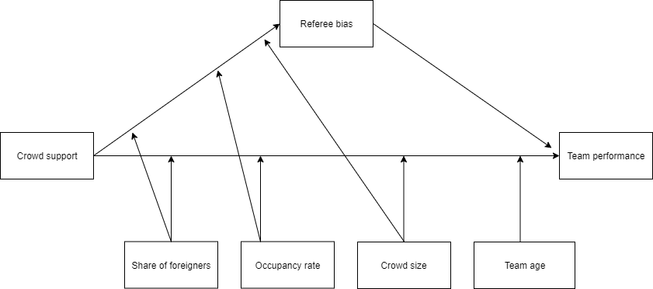

## 2.4 Hypotheses

In this section, we propose our expectations on the relationships between the variables in our model.

***Crowd support***

Crowd support can increase motivation for home players through loud and supportive cheers ( Ponzo & Scoppa, 2018). The increased motivation stimulates players’ effort they exert in the game. As a result, home teams perform better compared to away teams ( Ponzo & Scoppa, 2018). Away teams conversely, are negatively influenced by crowd support for the home team (Terry, Walrond & Carron, 1998).When backed by crowd support, players are more effective in their actions since they are motivated (Carmichael & Thomas, 2005). Link and De Lorenzo (2016) state that motivated players run faster, make more attempts to shoot, and take more sprints. This is in line with the theory of social facilitation mentioned by Zajonc (1965). He states that spectators can stimulate arousal and promote performance specifically for well-trained performers . Since soccer players are especially well trained in their profession we expect that crowd support can stimulate performance. Therefore, we generate the following hypothesis regarding the effect of crowd support on team performance:

***H1:*** *Crowd support positively influences home team performance relative to away team performance.*

***Referee Bias***

Referees have shown a consistent bias towards home teams when awarding fouls and cards. Referees are subconsciously influenced by crowd noise when making decisions on potential fouls, cards, and penalties (Nevill & Holder, 1999). Punishing home teams less severe in situations with crowd noise. Potential explanations include the use of visual cues when the situation is not very clear. The crowd’s reaction to a foul serves as a potential indicator of the actual situation and referees rely partly on these crowd judgments when making a decision. Additionally, referees could favor home teams to avoid potential crowd displeasure aimed at them during or after the game. In soccer, much more compared to other sports, one action can decide the entire game. A 1-0 win with a single shot on goal occurs frequently. Consequently, referee decisions have the potential to be decisive for team performance. A red card leaves a team weakened with fewer players and can change the entire game plan, tactics, and performance. We, therefore, hypothesize the following on the role of referee bias:

***H2:*** *The positive effect of crowd support on home team performance is mediated by a referee bias towards the home team.*

***Crowd size***

Crowds come in all shapes and sizes. Different crowds will have different influences on team performance. Bigger crowds in general, make more noise and can be more intimidating than smaller crowds. Crowd support has a direct effect on team performance and a larger crowd size is associated with louder crowd noise. This louder crowd noise could increasingly boost the confidence and motivation of the home team (Barnard, Porter, Bostron, TerMeulen & Hambric, 2011). The mechanism behind this could be explained by the common bond of solidarity introduced by Durkheim. (Durkheim & Halls, 1984). The solidarity shown by fans inspires players to improve their performance. Louder noise generated by larger crowds allows for a greater demonstration of solidarity (Smith, 2003). The greater solidarity and feeling of appreciation increases the ability of the home team to raise their performance above normal levels. (Schwartz & Barsky, 1977). Consequently, there is a larger performance boost for home teams that are backed by large crowds compared to teams supported by smaller crowds. This leads us to hypothesize the following:

***H3a:*** *The positive effect of crowd support on home team performance increases when crowd size increases.*

We expect crowd size to also play a notable role in the formation of referee bias. As mentioned in section 2.3, Nevill, Balmer & Williams (2002) in an experimental setting demonstrated the significant effect of crowd noise on referee decision making. Referees are more uncertain in their decisions when crowd noise is present, compared to situations where there is only silence. Favoring the home team in a situation with crowd noise by being more lenient in giving fouls and cards. Therefore, a bigger crowd size, with more crowd noise associated, will result in a stronger crowd noise effect. According to Nevill et al. (1996) “larger crowds are able to influence the referee into believing that away players have committed more fouls” (p.185). The stronger crowd noise will put heightened social pressure on the referee, which results in a stronger referee bias towards the home team compared to situations with less or no crowd noise. Therefore we hypothesize the following:

***H3b:*** *The mediating effect of referee Bias on the relationship between crowd support and home team performance increases when crowd size increases.*

***Occupancy Rate***

We expect crowd occupancy to be another important driver for the atmosphere within a stadium, and in turn for the effect of crowd support on team performance. If you play for 30,000 fans in a stadium where 100,000 fit, the atmosphere seems to be less intense and the stadium can appear to be almost empty. Conversely, teams that play in a small stadium which is sold out for each match will be more motivated. (Wankel, 1984) hypothesizes that empty seats convey a disinterest to participants at contests. On the other hand, teams that see the stadium filled up with fans might feel more appreciated by their fans and will be increasingly motivated to perform to their best. Thus the degree of occupancy could have consequences for the motivation and effort that players exert in the game ( Ponzo & Scoppa, 2016). Consequently, the associated performance boost for home teams as a result of crowd support will be lower when the occupancy rate is lower. Therefore we hypothesize the following on the effect of stadium occupancy on team performance:

***H4a:*** *The positive effect of crowd support on home team performance increases when the stadium occupancy rate increases.*

The occupancy rate can be meaningful in the materialization of the referee bias. Referees rely on visual cues and crowd reactions and with less crowd attending, referees are forced to rely more on their own judgment. Furthermore, referees are subconsciously favoring home teams because of fear of social repercussions from the crowd. (Dohmen & Sauermann, 2016). Matches played with a higher occupancy rate are associated with an increased atmosphere and ambiance. The increased intensity of the crowd’s support will result in added social pressure on the referee (Dawson & Dobson, 2010). As a consequence, the referee bias towards the home team becomes stronger compared to matches with lower occupancy rates. Therefore, we hypothesize the following:

***H4b:*** *The mediating effect of referee bias on the relationship between crowd support and team performance increases when stadium occupancy increases.*

***Share of foreigners***

Tilp and Taller (2020)mention soccer clubs recruiting players from all over the world as a potential reason for the decrease in home advantage over time. The globalization of football has led to an increased gap between fans and players. Fans and players, due to the increased differences in pay and origins, live in completely different realities from each other. Fans do not recognize themselves in the extremely rich and foreign players who play for their local team. Lower fan identification with a soccer team decreases the support of those same fans when attending the match. This decreases crowd cheering and thus crowd noise. As stated before, we theorize increased crowd noise to have a stronger effect on player motivation and thus team performance. Consequently, we hypothesize the following regarding the effect of the share of foreigners within a team on team performance:

***H5a:*** *The positive effect of crowd support on home team performance is weakened when the share of foreigners increases.*

We expect the share of playing minutes for foreigners to also be relevant for referee bias. A team with a high share of foreign players makes it harder for the home crowd to bond with their team, producing a less intense atmosphere in the match and consequently less crowd noise. As we established before in section 2.3, the referee bias in favor of home teams is primarily determined by crowd noise and crowd reactions. If the crowd noise is less and crowd reactions are less intense, referees will be more reliant on their own judgments and less influenced by the crowd. Consequently, the referee will be less biased towards home teams when the crowd noise is lower than in situations of a more intense atmosphere. Accordingly, we construct the following hypothesis:

***H5b****: The mediating effect of referee bias on the relationship between crowd support and team performance is weaker when the share of foreigners increases.*

***Team age***

The degree to which crowd support will influence team performance will vary per team. Each player reacts differently to playing environments. Team composition thus seems to play a role. Van de Ven (2016) finds that experienced sides with older players tend to perform better away from home than inexperienced sides. Possible reasons could include familiarity with the away venue and more experience with hostile crowds. Older players who have more experience, especially when that experience is within the same league, will be more familiar with venues and could be more experienced with home crowds. Older players can also develop coping strategies to decrease the influence of opposition crowds on their performance when playing away (Russell, 1983). Younger players also might suffer increasingly from stage fright (Steptoe & Fidler,1987). Which could hamper their performances. Thus, the older the away team, the weaker the effect of crowd support on home team performance relative to away team performance. Based on the literature and theory we formulate the following hypothesis:

***H6:*** *The positive effect of crowd support on home team performance relative to away team performance decreases with away team’s age relative to home team’s age.*

## Data and Methodology

## 3.1 Data collection

The website ([http://www.football-data.co.uk](http://www.football-data.co.uk/data.php)) provides weekly updated data sets for all important leagues around the world. The data sets include statistics on full-time and half-time results, shots, shots on targets, number of fouls, number of yellow cards, red cards, and corners for each team on match level. Our sample includes all the matches played from season 2018/19 onwards. We chose 2018/19 as the cutoff as around this time the VAR got introduced to most competitions (Farrell, 2019). The VAR has major implications, especially in the realm of crowd support’s influence on decision making by referees. The referee can be overruled by the video referee, often located outside of the stadium, and thus less influenced by crowd noise.

We picked the top 10 leagues in European soccer to be included in our sample. Afterward, we decided to remove the Russian Premier League from our analysis since data on our moderating variables was unavailable for the Russian Premier League. The 9 leagues incorporated are the Dutch Eredivisie, German Bundesliga, Portuguese Primeira Liga, The Turkish Super Lig, Belgian Jupiler League, French Ligue 1, English Premier League, Spanish Primera Division, and the Italian Serie A. We added a dummy variable equal to 0 for the leagues where the VAR had not been introduced yet. This was only the case for the 2018/19 Premier League and 2018/19 Primeira Liga seasons. For data on our moderators - team average age, percentage of foreigners, crowd occupancy, and crowd size - we consulted the website transfermarkt.com. We use points difference as main indicator of team performance since points obtained are the primary outcome of a soccer match. We also add goal differences to perform robustness checks.

We need to control for potential endogeneity resulting from other variables affecting team performance. Team performance depends heavily on the quality of the team (Lago-Peñas & Lago-Ballesteros, 2011). Thus a measure of team strength should be included in the model as a control variable. The most comprehensive measurement of team strength we know, is the Soccer Power Index(SPI) used by FiveThirtyEight[3], used by among others McCarrick et al (2020). FiveThirthyEight’s SPI index is constructed by computing an offensive and defensive rating. This rating is equal to the number of goals expected to score/concede by the team against an average opponent on neutral ground. The SPI is then defined as the percentage of points that the team will take if the match against an average team on neutral ground is played. FiveThirtyEight’s public GitHub repository provides a weekly updated data set with SPI data. Another variable influencing team performance is the importance of a match. Link & de Lorenzo (2016) discovered that players make more and faster runs in matches that were influential on final ranking compared to matches that were not. Intuitively it makes sense that a team will attempt to reach peak performance for a match that is important and be less focused and motivated when the outcome of the match has no consequences. The SPI data set also includes a measure of match importance for both the home and away team. The match importance is calculated by combining the expected probabilities of match outcomes that would alter the ranking of the team in the competition.

For our regression model on referee bias, a potential confounding variable is the dominance in a match. Dominant teams with more possession will make fewer fouls within a match (McCarrick et al 2020; Goumas, 2014b). If home teams play more attacking soccer and therefore need to commit fewer fouls, the referee bias we found might simply be a result of playing style and not from an actual bias in referee decision making. We include the difference in shots between home and away teams to control for dominance.

Since our sample features matches from multiple leagues, there is a possibility for league specific differences to arise. \ However, McCarrick et al. (2020) downplay the importance of league given differences, stating that “given the homogeneous nature and operating conditions of the sample (i.e., elite athletes playing under the same football laws), it is doubtful that even if data were available few differences would either arise or be statistically detectible between leagues due to power issues” (p. 10). McCarrick et al. (2020) base their reasoning on previous work on statistical power analysis by Cohen (1992) and Mooijaart (2003). Therefore, we decide to not include country fixed effects into our model.

## 3.2 Variable Operationalization

In table 2 we provide an overview of the main variables included in our analysis, with an explanation of how the variable is operationalized. Our unit of analysis is a match between two soccer teams, with the team playing at home called “Home Team” and the team playing away “Away Team”. For many of the variables, we use the differences between home and away statistics to reduce the number of variables used in our models. For the majority of these variables, we calculate the difference by subtracting away values from home values. For example, goal difference is calculated as the number of goals scored by the home team minus the number of goals scored by the away team. However, for variables related to referee bias, we decided to reverse the calculation to facilitate interpretation of outcomes. When calculated in this way, a positive difference in cards implies higher cards for away teams, which can be seen as a positive bias towards home teams.

**Table 2**



## 3.3 Descriptive statistics

Table 3 provides the descriptive statistics for the variables mentioned in section 3.2.

The data set contains match data for 8,137 matches played in 9 major leagues in Europe. We observe that home teams on average score .292 goals more and collect .365 more points compared to away teams. Furthermore, the table reveals that home teams on average receive .185 fewer yellow cards and .026 fewer red cards than away teams while committing .108 fewer fouls on average. Appendix 1a contains the full summary statistics table.

**Table 3**



## 3.4 Home advantage with and without crowd support

For the entire sample, there is a clear difference in performance between home and away teams, with more points, and more goals for home teams over the past 3 years. However, solely based on the entire sample, we cannot conclude whether this difference remained during the matches played without crowd support. Therefore we split the data set into two different data sets. One data set containing matches only played before the start of the Covid-19 pandemic and the other only containing matches played during the Covid-19 pandemic. 2,996 of the matches have been played behind closed doors and 5,141 have been played with spectators.

We proceed with statistical tests to examine whether team performance has changed significantly during the Covid-19 pandemic. To determine the right statistical test ,we first check our variables for univariate normality. In appendix 2a we see that these tests highlighted that all our variables are non-normal. Due to the continuous nature of our variables we use a Mann-Whitney U test, which handles our non-normal data better than traditional t-tests (De Winter, & Dodou, 2010). For the percentage of home and away wins, which are coded as categorical variables, we perform a chi-square test of comparison. Table 4 contains the mean values for our variables of interest accompanied by p-values for the null hypothesis of equal distributions.

**Table 4**

*****Note*: Statistic is the Mann-Whitney Estimate, tests 0 hypothesis of equal distribution. Significance levels: *p* < .05* , *p* < .01 **, *p < .001* ***

The gap between home and away teams for both expected and actual goals has declined significantly following the disappearance of crowd support. Table 4 proves that with supporters, home teams scored .36 more goals than away teams per match, a number that fell to .17 (*p* < .001) when crowd support was absent. For expected goals, we see a similar drop from .31 to .16 (*p <* .001). Table 4 also shows the differences in referee punishments between matches played with and without crowd support. compared to matches with crowd support, in matches without crowd support, the difference in yellow cards has been reduced by .3 (*p* < .001), the difference in red cards by.02 (*p* = .010) and the difference in fouls has by .5 (*p* < .001) relative to away teams. These results imply that away teams have been punished less severely relative to the home team in matches without crowd support. These differences are depicted in figure 2, clearly highlighting the change in referee decisions in matches without fans.

Figure 3 shows the trend in the differences in yellow cards between home and away teams. We observe a significant dip in the few months after the start of the Covid-19 pandemic. However, towards the end of 2020 we see the difference decreasing again, to remain relatively stable in 2021. This suggests that the effect of missing supporters was the heaviest right after the restart, with referees adjusting to the new situation afterward. Appendix 3b shows a similar but less extreme drop in foul difference immediately after the start of the Covid-19 pandemic. For the red card difference, however, as we can observe from appendix 3a, there is no clear pattern visible. This is probably caused by the low number of red cards per game.

**Figure 2**

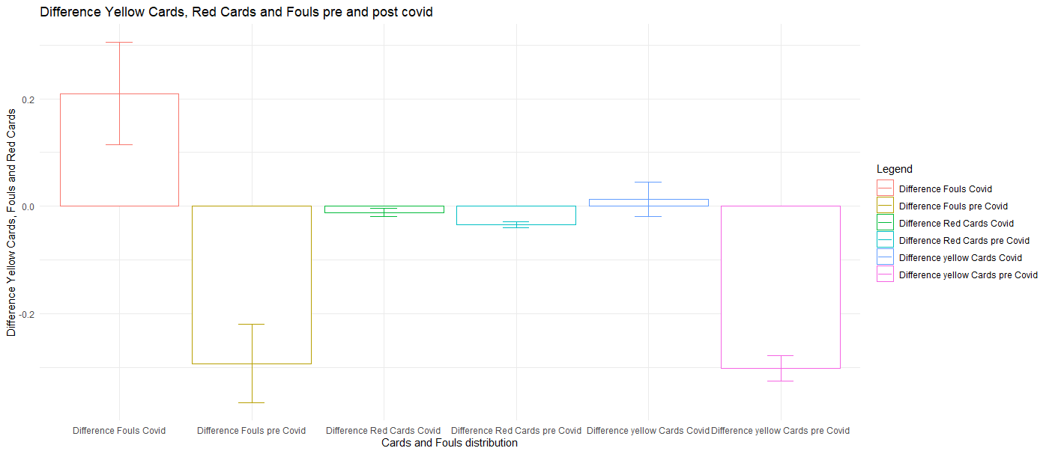

*Note:* for each pair of bars, the left bar represents the level during the covid pandemic, with the right bar representing the levels before the pandemic. From left to right, we compare Fouls, red cards, and yellow cards. Error bars represent a 95% confidence interval for mean value.

**Figure 3 The difference in Yellow Cards over time**

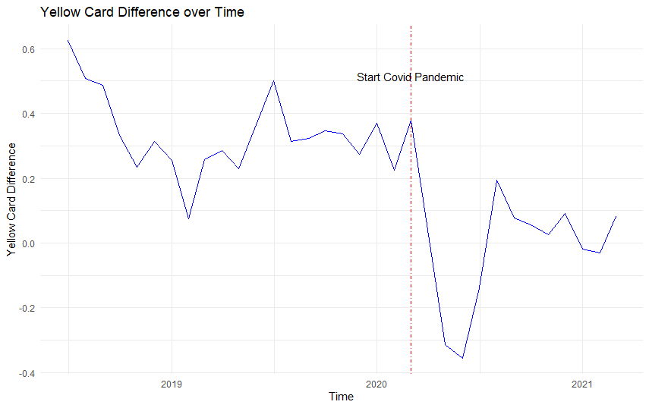

*Note*: the blue line indicates the average yellow card difference per month. The vertical red dashed line indicates the start of the Covid-19 pandemic.

Our statistics on differences show that there has been a significant reduction between home and away teams on various metrics. However, it does not show whether these differences stem from reduced home team performance or increased away team performance. Or in the case of referee decisions, whether the differences come from a reduced punishment for away teams or increased punishment for home teams. We delve deeper into the home and away team data to uncover these patterns. Table 5 presents the results for referee decisions. The results in the table are revealing in several ways. Firstly, it seems that rather than punishing home teams more severely, the gap in cards has mainly been reduced by a more lenient attitude towards away teams. They receive significantly lower numbers of yellow and red cards since the start of the pandemic, while not making significantly more fouls. Secondly, somewhat contradictory to the first finding, is that despite the significant increase in fouls made by the home team, the number of cards the home team received remained relatively stable. This could be interpreted as a less severe punishment for fouls, or perhaps that home teams made more minor fouls that were not serious enough to be a bookable offense.

**Table 5**

*****Note:* Statistic is the Mann-Whitney Estimate, tests 0 hypothesis of equal distribution. Significance levels: *p* < .05* , *p* < .01 **, *p < .001* ***

To distinguish between differences in home and away performance, we provide different metrics of team performance from both a home team and away team perspective. As shown in table 6, the performance of home and away teams has changed significantly after the disappearance of crowd support. The percentage of wins at home declined by 5 percentage points from 45 percent to 40 percent (*p <*.001*)* whereas the percentage of away wins rose from 30 to 34 percent (*p <*.001*)*. The chi-square proportion for the difference in proportions of home and away wins gives a chi-square value of 74.252 (*p <*.001) which suggests that home advantage indeed has significantly decreased following the exclusion of supporters.

The number of goals and points for home teams also declined substantially. Away teams fare better in games behind closed doors compared to games with fans. With crowd support, away teams on average collected 1.15 points per game, scoring an average of 1.22 goals per game in the process. When crowd support is not present, however, away teams have increased their points per game to 1.27 (*p <*.001) also increasing the number of goals scored on average by 0.08 to 1.30 goals per game(*p <*.001). There is clear evidence of changes in team performance for both home and away teams following the exclusion of fans.

**Table 6**

*****Note: ^ = chi square statistic, others = Mann-Whitney estimate. ,* Significance levels: *p* < .05* , *p* < .01 **, *p < .001* ***

We also examine differences in expected goals. Metrics such as goals and points provide information on team performance but can be dependent on luck in finishing. Expected goals is a metric that calculates the quality of chances created by a team over the entire match and therefore is very suitable to evaluate team performance. In the long run, expected goals and actual goals always converge to the same value (Rathke, 2017). The decrease in home advantage seems to come from both an increase in away team performance and a decrease in home team performance. Home team’s expected goals dropped substantially by .1 (*p* <.001) per game in matches without spectators. Away teams expected goals rose from 1.25 to 1.30 (*p* = .043*).*

The differences in goals and expected goals are displayed in figure 4. On average, we observe a significant decline in the expected goals difference and goal difference in games without crowd support. From figure 5 we observe a sharp drop in expected goals difference immediately after the start of the pandemic. However, contrary to referee decisions, we do not see a movement back towards pre-Covid-19 levels as expected goals difference remain quite low. For points and goal difference on the other hand, as shown in appendix 3c and 3d, we see a substantial increase after the initial drop.

**Figure 4**

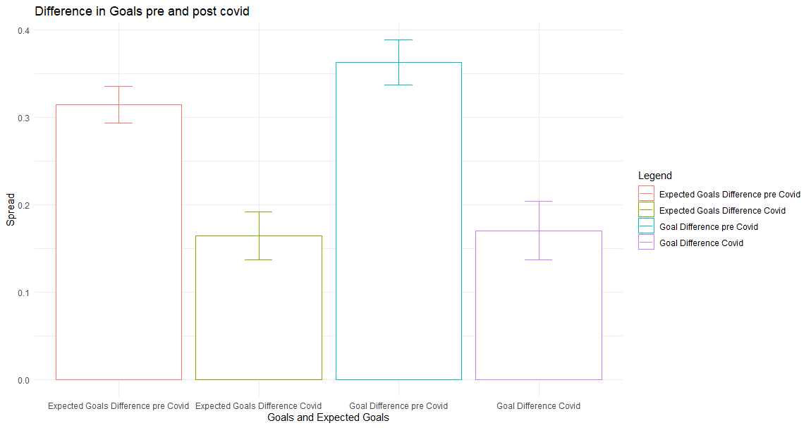

*Note:* for each pair of bars, the left bar represents the level before covid and the right bar the levels after covid. From left to right we compare Expected goals and Goals. Error bars represent 95% confidence interval for mean value.

**Figure 5**

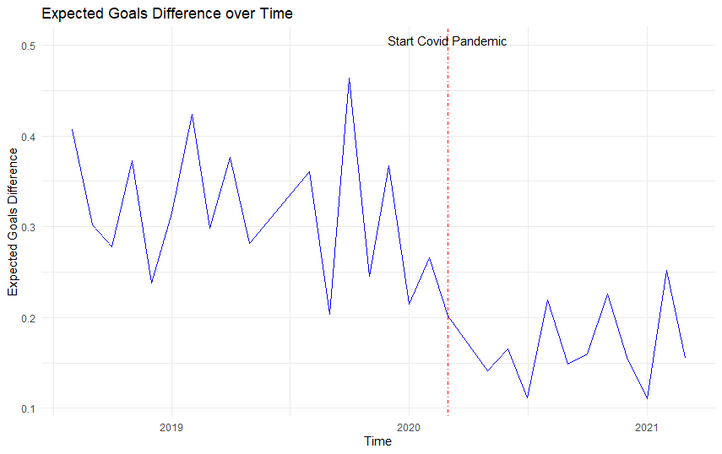

*Note:* the blue line indicates the mean difference in expected goals per month. The red dashed line indicates the start of the covid

pandemic.

## 3.5 Model

Our model-free evidence indicates a significant alteration in team performance in matches played without crowd support. However, based on these numbers we cannot make conclusions about causal mechanisms. In the next chapter, we examine whether the absence of crowd support was the driver of the drop in home team performance relative to away team performance. In our model, we scrutinize the possible mediating role of referee bias in this process. Moreover, we check for the effects of multiple moderating variables: stadium occupancy, crowd size, team age, and the share of playing minutes for foreigners for a team. Finally, we add control variables for team strength, match importance, and VAR availability. Our first equation involves the path between our independent variable crowd support and our mediating variable, referee bias.

Referee bias will enter the model as a latent construct measured from foul and yellow card decisions by the referee. We decided to exclude red cards from the construct since the Cronbach’s Alpha for a latent construct comprising only of yellow cards and fouls is considerably higher(.32 vs .25). Table 7 shows the results of the scale reliability analysis for our latent construct. The benchmark value for Cronbach’s Alpha is .7 (Nunnally, 1978). Despite our value not reaching the benchmark value we decided to keep the latent construct within our model. We deem it important that an abstract concept such as referee bias is measured by combining multiple variables. In the next chapter, we perform a robustness check for our model by deploying the same model with only the observed variable yellow cards instead of the latent referee bias.

**Table 7**



Below are the regressions equations for our model..

**Equation 1:** Referee Bias: *β0 + β1Covid + β2OccupancyRate + β3ForeignersShareDifference + β4Crowdsize + β5Covid*OccupancyRate + β6Covid * ForeignersShareDifference + β7Covid * Crowdsize + β8RatingDifference + β9ImportanceDifference + β10VAR +β11ShotsDifference + ɛ*

The second equation within our model is the path between our independent variable crowd support and our dependent variable team performance. We use 2 different measures of team performance to increase the robustness of our results.

**Equation 2:** Team Performance *= β0 + β1Covid+ β2OccupancyRate + β3ForeignersShareDifference + β4Crowdsize + β5AgeDifference + β6 Covid*OccupancyRate + β7 Covid * ForeignersShareDifference + β8 Covid * Crowdsize + β9 Covid * AgeDifference + β10RatingDifference + β11ImportanceDifference + β12VAR +β13Referee bias + ɛ*

We deem a structural equation modeling approach (SEM) most suitable for our analysis since we want to assess multiple relationships and also include a latent construct within our model. Hair, Black, Babin, Anderson, and Tatham (2014) state the main advantage of SEM vis-a-vis other powerful techniques such as multiple regression and factor analysis is that SEM allows for the examination of multiple relationships together simultaneously. Furthermore, SEM allows both latent and observed constructs in the model. We use the Lavaan package in R to conduct our analysis.

## Analysis and Findings

In this chapter we deploy our previously defined model on our data set to examine the causal relationships within our conceptual framework. We start by checking the assumptions.

## Assumptions

Our total sample of 8,137 matches is reduced to 8,054 due to missing data for match importance. Since our sample contains such a large amount of observations, we rely on the central limit theorem of Brosamler (1985) to conclude that our sample is robust for deviations for normality. Therefore we proceed with the 2 other assumptions, Multicollinearity and Heteroscedasticity.

**Multicollinearity**: When interpreting the correlation table in appendix 7 we see a few high correlations. Notably between our control variable Rating difference and our dependent outcomes, as well as the correlation between Rating Difference and Importance Difference. Furthermore, there exists a correlation of 0.75 between occupancy rate and average attendance, which makes sense since these variables are closely related. We calculate the variance inflation factors for our model variables. The results are shown in appendix 6. A frequently used benchmark for VIF values is 10 (Vittinghof, Glidden, Shiboski, and McCulloch, 2011). James, Witten, Hastie, and Tibshirani(2013) on the other hand pose a value of VIF over 5 to be problematic. The highest VIF factor within our model is 4.67. Therefore we can safely assume that multicollinearity is not a problem within our model.

**Homoscedasticity:** The assumption of homoscedasticity is important for the ability to interpret standard errors of our model. We use the Non-Constant Error Variance test to test for homoscedasticity within our sample. As we observe from appendix 5, for both our equations, the test statistic is insignificant (*p* =.15 and *p* = .76) and as such conclude that the assumption of homoscedasticity is met in our model.

We mean-centered all our moderating variables to ease interpretation of the moderating effect on the relationship between crowd support and team performance (Iacobucci, Schneider, Popovich & Bakamitsos, 2017). Additionally, since some of the moderating variables within our model are measured on different scales, we standardize them as well.

## Results overview

Table 8 displays the results of our model, with the difference in points between home and away teams as the dependent variable. To ensure the stability of our findings we generated 5,000 bootstrap samples, which is well above the general minimum value of 500 and thus considered acceptable (Cheung & Lau, 2008). As stated in the introduction, the main goal of our study was to examine whether crowd support has a significant effect on team performance. As we can observe from the table, the absence of crowd support has a negative significant influence on points difference ( *β* = -.285, *p* < .001). This implies that the disappearance of crowd support decreases the points gap between home and away teams by .285 points per match. This effect is enhanced by the stadium occupancy rate (*β* = -.197, *p* = .003*).* Teams with higher occupancy rates got hit harder by the fact that crowd support disappeared during the Covid-19 outbreak. This also implies that in matches where crowd support is present, they have a bigger home advantage all else equal, and thus perform better compared to teams with low occupancy rates.

**Table 8**



We do not find a significant role for crowd size however (*β* = .042, *p* = .528*).* Apparently, a larger crowd size does not result in a larger boost from crowd support in team performance. The presence of a home crowd increases home team performance but whether this is a crowd of 500 or 50,000 might be not important for soccer players. This could explain the fact that home advantage still exists at amateur levels, with very small crowd sizes in general (Carron, Loughhead & Bray, 2005). We also do not find significant effects for both player age(*β* = -.074, *p* = .179*)* and the share of foreigners(*β* = -.011, *p* = *.*852*).* Since van de Ven(2016) concluded that the effect of age was relatively small, the insignificant role for average age is not entirely unexpected. Moreover, the average age of the teams was quite close to each other, with the difference between the 25th and 75th percentile being 1.9 years such that variation between teams is quite low. For the share of foreigners, allegedly, it does not exert enough influence on stadium atmosphere to affect team performance. A possible explanation may be that crowds got used to the new situation where they root for players around the world rather than their local players. Another possible reason for this is that they do not care whether they root for local heroes or foreign players but care about the club.

Table 8 also shows the results for the mediation analysis we used to examine the role of referee bias in the dynamic between crowd support and team performance. We find that part of the effect of crowd support on team performance is channeled through referee decisions (*β* = -.019, *p* = .005), During the Covid-19 pandemic, where crowd support was absent, the referee bias towards home teams decreased and therefore reduced the point gap between home and away teams. However, the percentage of the total effect of crowd support on team performance that is mediated by referee bias is quite low at 6.67%. We do not find evidence for moderated mediation. Crowd occupancy(*β* =.001, *p* = .714), crowd size(*β* = -.001 , *p* = .752) , and the share of foreigners(*β* = -.001 , *p* = .789) do not change the effect of crowd support on referee bias. The sole fact that a home crowd is present leads to an increased referee bias in favor of home teams, yet, the number of home fans, the share of foreigners, and the degree to which the stadium is filled do not affect the bias.   
 The control variables importance difference and rating difference have face-valid effects. All else equal, a higher rating(*β* = .059, *p <* .001) for the home team and a higher match importance for the home team(*β* = .003, *p <* .001) increases the points difference between home and away teams. This makes sense, better teams will collect more points on average, and a team for whom the match is more important will be more motivated to play well and win the match. The rating difference as expected also plays a significant role in referee decisions (*β* = .022 , *p* < .001), as does the shots difference (*β* = .019 , *p* < .001). VAR does not play a significant role for either points difference (*β* = .069, *p* = .473) or referee bias (*β* = .092 , *p* = .330).

**Table 9 Fit indices**



Table 9 provides an overview of the fit indices for our moderated mediation model. Our chi-square statistic of 107.041(*p* <.001) suggests a discrepancy between the actual and predicted observations. However, Kyriazos (2018) mentions the sensitivity of the chi-square statistic to sample size. Since our sample of 8,054 is quite large we decided to ignore the chi-square statistic measure of fit. To benchmark the goodness of fit of our model, we use the standard that Dion(2008) provides in his paper on preferred values for the major fit measures of SEM.

He proposes that the Tucker-Lewis index(TLI) measure should approach 1 preferably, our TLI has a value of .911 which is not great but not terrible either. Secondly, the comparative fit index (CFI) should have a minimum value of .90 for a model to be considered a “good fit”, Our CFI measure has a value of .966, which is above the desired cut-off value. We conclude that for this second metric our model seems to be acceptable. Thirdly, Root mean square error of approximation(RMSEA) is a measure of the difference in the sample data with what would be expected in the situation of a correct model. Thus for RMSEA, a lower value is preferred. In general, .05 is regarded as the maximum acceptable value. Our value of .027 falls well within the acceptable range. The final measure we use is Standardized Root Mean Squared Residual (SRMR), which is the standardized difference between predicted and observed correlations (Taasoobshirazi & Wang, 2016). Similar to RMSEA, the cut-off value is .05. With a value of .010, our model appears as a good fit for the data. Overall our model seems to fit reasonably well, passing 3 out of 4 fit statistic cut-offs.

## 4.3 Robustness check

To ensure the robustness of our results, we deploy our model on a second measure of team performance. The points difference between home and away teams is the primary outcome metric of a soccer match. We are also interested in goal difference because not all wins are the same. A narrow win by just one goal and a thumping four-goal victory both have the same points result but a very different match process. Perhaps while home and away wins are evenly divided, every away win could be a scrappy 1-0 whereas all home wins end in 3-0 . In this case, there is still a home advantage.

Appendix 8a shows the results of our model with goal difference as a dependent variable. Some coefficients slightly change in estimation but all the signs and significance levels remain similar. Thus, our findings not only hold for point differences but also for goal differences. This strengthens the validity of our model findings.

Furthermore, we check the robustness of our results for different measures of referee bias. As mentioned before, the internal scale reliability of our latent construct is quite low, therefore we check our model results with yellow card difference as mediating variable. The results are shown in appendix 8b and 8c for both points and goal difference. Some coefficients change slightly but again, we see no major differences. To compare the two latent structures, one with yellow cards and fouls included and one with yellow cards, fouls, and also red cards, we test one model that also includes red cards. The results for this model are shown in appendix 8d, with coefficients and p-values remaining similar. Appendix 9 depicts the fit measures for our robustness checks. Similar to before, we decided to ignore the significant chi-square statistic. For the other 4 fit measures, our models fit well to the data according to 3 out of 4 criteria. Only the model that includes red cards in the latent construct scores noticeably worse on the fit measures, which strengthens our decision to remove red cards from the models we use to base conclusions on.

## 4.4 Moderating effect occupancy

Having ensured the robustness of our results, we scrutinize the effect of our only significant moderator crowd occupancy on the relationship between crowd support and team performance. We use the simple slope analysis introduced by O’Connor (1998) to compare the differences between high and low levels of crowd occupancy. The standard levels used in the literature for high and low levels of a variable are one standard deviation below and above the mean (O’Connor, 1998). Table 10 shows the differences in the total effect of crowd support on team performance for high, low, and medium levels of crowd support.

For both our measures of team performance, the effect of crowd support on team performance is significant for high and mean levels of Occupancy. However, for low levels of crowd occupancy the effect of crowd support on team performance is not significant. This implies that teams with low stadium occupancy rates did not see a significant alteration in their performance during in matches without supporters.

**Table 10**



Note: Significance levels: *p* < .05* , *p* < .01 **, *p < .001* ***

For mean levels of occupancy rates, the decrease in the points gap during the pandemic is -.285. For high levels of crowd occupancy, this effect is nearly twice as large with the decrease in points gap having a value of -.482. Thus, teams with high occupancy rates before the Covid-19 pandemic suffered more from the absence of crowd support than teams with low or average occupancy rates. Conversely, teams with higher occupancy rates have a bigger home advantage when crowd support is present. For Goals, we see that for low levels of crowd occupancy the gap between home and away goals is again not significantly different during the Covid-19 pandemic. For teams with a high level of crowd occupancy, the gap in goals decreases by .359 per match while for mean occupancy levels the decrease was .202. Again, we see that teams with high occupancy rates have been more heavily affected by the exclusion of home supporters.

## Conclusion and Discussion

## 5.1 Conclusions

We document the effect of crowd support on team performance. We used the extraordinary opportunity of the Covid-19 pandemic to systematically scrutinize a large number of matches played without fans to directly assess the impact of crowd support on team performance. We first used several descriptive metrics of referee decisions and team performance to uncover whether they were significantly different in matches with crowd support compared to matches without crowd support.

Both home and away team performance have been affected following the absence of crowd support. Home teams score fewer goals, create fewer chances and obtain fewer points per game. Away teams, seem to have increased their effectiveness, scoring significantly more goals and having a significantly higher expected goals tally without having more shots or more shots on target.

Referees give fewer cards to away teams in matches without supporters while cautioning home teams not different than when fans are present. The number of fouls for away teams remained stable in matches with and without crowd support while the number of fouls for home teams increased following the exclusion of away supporters. Subsequently, we proceeded to assess causality links between crowd support, referee bias, and team performance while including multiple moderating variables. Given the complexity of our model, we used a structural equation modeling approach to effectively model the relationships between our observable variables and the latent construct referee bias.

Table 11 provides a summary of our hypotheses generated in chapter 2 and the evidence we find for the hypotheses in our analysis. We find that crowd support significantly affects team performance, with the points gap reduced by .285 and the goals gap reduced by .202 following the exclusion of supporters. We further propose that crowd occupancy but not absolute crowd size affects the degree to which crowd support influences team performance. With higher occupancy rates the points gap was reduced by.482 whereas the goals gap was reduced by .359. This in comparison to lower occupancy rates for which the points and goal gap did not change significantly following the removal of crowd support.

We also discover that crowd support not only directly influences team performance but also affects team performance indirectly through referee decisions. Roughly 7% of the total effect of crowd support on team performance is channeled through a referee bias. We do not discover evidence that crowd size and crowd occupancy influence the relationship between crowd support and referee bias. Furthermore, we do not find evidence to support the claims that the share of foreigners and the average age of teams influences the effect of crowd support on team performance, nor the effect of crowd support on referee decisions.

**Table 11**



## 5.2 Managerial implications

Our thesis has several managerial implications. Marketing managers at soccer clubs can use our insights to to take the effect of their decisions on team performance into consideration. Our research shows that not crowd size but crowd occupancy matters for home advantage. The most important task for a marketing manager thus is to deploy the right marketing strategies to fill the stadium as much as possible. Marketing managers who can effectively bring fans to the stadium can positively impact team performance.

A decrease in point gap of .5 in practice implies that home teams collect .25 fewer points and away teams collect .25 more points. In a season of 38 games, a team with a high occupancy rate compared to a team with a lower occupancy rate could collect as much as 4.58 (19 home games * ((.482-0)/2)) points more in home games solely because of the higher occupancy rate. With differences between teams close to each other in the league table often being very marginal, these four or five or even one or two extra points could be the difference between qualifying for the Champions League rather than the Europa League or between relegation and staying in the league. In the season 2018/19, for all of the leagues in our sample, three extra points would have helped at least one and often more of the relegated teams to stay up in the first division. Similarly, for all of the leagues apart from the Dutch, Belgian and Portuguese ones, the teams with Europa League spots would have secured a Champions League spot instead. Both of the outcomes have huge financial consequences. The Champions League guarantees clubs an income of €15.25 million for participation alone with the option of millions in bonuses for winning matches and reaching further into the tournament. The Europa League on the other hand offers a mere €2.92 million starting fee and considerably lower bonuses.[4] Relegation has similar consequences, with Sky Sports estimating the estimated loss in TV revenues for Premier League clubs relegating to the Championship to be at least £50 million.[5] A huge number that does not even account for potential losses in commercial deals.

Our findings have implications for other big decisions for soccer clubs. A lot of clubs spend a plethora of resources on the development of larger stadiums to increase attendances and consequently ticket revenues. Given the impact of occupancy rates, rather than trying to increase revenues by moving to bigger stadiums, a more viable strategy could be to remain in the same stadium to increase or ensure high occupancy rates. The remaining fans can be catered through attractive online engagement strategies and match coverage on TV. Potential future developments such as streaming services for broadcasting soccer matches could provide opportunities for marketing managers to increase customer revenue while optimizing stadium occupancy rates.

Our analysis also offers insights on the lack of influence of foreign players on crowd atmosphere and fan engagement. As a consequence global marketing strategies to increase the global presence and increase associated revenue streams through for example social media engagement can then be used to generate more revenue. As such, buying foreign players from countries all over the world to increase fan engagement could be a viable option for soccer clubs. This strategy could be combined by hiring young local talents from parts around the world for low prices since our results show that crowd support does not affect team performance differently for players aged differently. Excellent examples of how clubs can integrate such strategies include Ajax increasing their presence in Brazil through the purchase of local young talents David Neres and Anthony. The welcome song that Ajax posted was well received and gained global attention, increasing the engagement with fans around the world, especially in Brazil.

## 5.3 Limitations and areas for future research

In the context of the widely used expression “no research is perfect research”, our study imposes several limitations, and subsequently, areas for future research.

First, our moderators were limited in data availability. Teams play with different starting elevens per match, which changes the average age and the share of foreign playing minutes on a match basis. Similarly, different matches attract different crowds, depending on the opponent, day and time of kick-off etc. Consequently, occupancy rates and crowd sizes vary per match. We decided to use season-wide measures due to the availability of the data and time concerns. Match level data would have been very cumbersome to collect. Possible methods to improve the reliability of the effects of the previously mentioned variables could be web scrapers scraping match specific data for more precise data on these variables, to then conduct a similar study to this one.

A second area for future research could be a large-scale factor analysis for team performance and referee bias. We used 2 separate measures of team performance with goal difference and points difference. Furthermore, the Cronbach’s alpha for the latent construct referee bias we use in this study is quite low. These are clear limitations of this study. There are multiple other measures of team performance and referee decisions that we did not include in our analysis. For team performance, there are outcome level measures such as we investigated but also deeper-lying performance metrics such as shots, possession, and expected goals. For referee bias, we did not have data on measures such as penalties, extra time, and more detailed data such as erroneous decisions made by referees.

Third, in our study, we established the importance of occupancy rates on team performance. Future studies could include more extensive research on the factors that drive fan behavior and stadium attendance. This could provide management with more specific recommendations. For example, a deeper understanding of their team’s fan base can help marketing managers improve customer targeting and improve the marketing efforts for soccer clubs. This enhances the ability to attract customers to the stadium as well as an increased fan engagement and consumption.

Fourth, in this thesis, we observed dramatic changes immediately after the start of the Covid-19 pandemic for a few of our metrics. Notably yellow cards and goals. However, we did not delve deeper into time analysis, which could be an interesting topic for future research. Adding a variable that counts the number of home matches played by the home team since the restart and let it interact with a crowd support dummy would shed light on whether there are significant differences over time. Perhaps the referees and players got used to playing behind closed doors such that the effects on team performance would diminish in later matches.

Fifth, we decided to not include country fixed effects in our model. We include multiple countries in our analysis which could potentially give rise to country specific differences within the data. We base our decision on the the literature that mentions that soccer matches are of such uniform nature across countries that few differences would probably show up or be significant (Cohen, 1992; Mooijaart, 2003; McCarrick et al. , 2020). Despite this we acknowledge that it is possible that our results might have been influenced by not including country fixed effects.

Finally, in our study, we use the share of foreigners to scrutinize whether increased globalization within soccer affects the influence of crowd support on team performance. However, a second way through which this increased globalization of soccer clubs could influence the atmosphere within the stadium is through the composition of the crowd itself. “Football Tourism” is a well-known term that signifies the influx of global supporters at renowned European clubs at home matches (Graakjær & Grøn, 2020). The main objective for these supporters is the experience of visiting a match and not necessarily rooting for the home team to win. An intriguing area for future research could be to examine the impact of football tourism on crowd atmosphere and team performance.

Despite its limitations this study offers valuable insights into the relationship between crowd support and team performance. We uncover that marketing managers can influence their team’s performance by as much as 4 points by increasing the stadium occupancy rate.

# 6. Bibliography

1. Adcroft, A., Teckman, J., & Madichie, N. (2009). Management implications of foreign players in the English Premiership League football. *Management Decision*.
2. Agnew, G. A., & Carron, A. V. (1994). Crowd effects and the home advantage. International Journal of Sport Psychology
3. Allen, M. S., & Jones, M. V. (2014). The home advantage over the first 20 seasons of the English Premier League: Effects of shirt colour, team ability and time trends. *International Journal of Sport and Exercise Psychology*, *12*(1), 10-18.
4. Barnard, A., Porter, S., Bostron, J., TerMeulen, R., & Hambric, S. (2011). Evaluation of crowd noise levels during college football games. *Noise Control Engineering Journal*, *59*(6), 667-680.
5. Boyko, R. H., Boyko, A. R., & Boyko, M. G. (2007). Referee bias contributes to home advantage in English Premiership football. Journal of sports sciences, 25(11), 1185-1194.
6. Brechot, M., & Flepp, R. (2020). Dealing with randomness in match outcomes: how to rethink performance evaluation in European club football using expected goals. Journal of Sports Economics
7. Brosamler, G. A. (1988, November). An almost everywhere central limit theorem. In *Mathematical Proceedings of the Cambridge Philosophical Society* (Vol. 104, No. 3, pp. 561-574). Cambridge University Press.
8. Carmichael, F., & Thomas, D. (2005). Home-field effect and team performance: evidence from English premiership football. Journal of sports economics, 6(3), 264-281.
9. Carron, A. V., Loughhead, T. M., & Bray, S. R. (2005). The home advantage in sport competitions: Courneya and Carron's (1992) conceptual framework a decade later. *Journal of sports sciences*, *23*(4), 395-407.
10. Cheung, G. W., & Lau, R. S. (2008). Testing mediation and suppression effects of latent variables: Bootstrapping with structural equation models. *Organizational research methods*, *11*(2), 296-325.
11. Cohen, J. (1992). Statistical power analysis. Current directions in psychological science, 1(3), 458 98-101.
12. Clarke, S. R., & Norman, J. M. (1995). Home ground advantage of individual clubs in English soccer. Journal of the Royal Statistical Society: Series D (The Statistician), 44(4), 509-521.
13. Csikszentmihalyi, M. (1990). Flow: The psychology of optimal experience. New York, NY: Harper & Row.
14. Dawson, P., & Dobson, S. (2010). The influence of social pressure and nationality on individual decisions: Evidence from the behaviour of referees. *Journal of Economic Psychology*, *31*(2), 181-191.
15. De Winter, J. F. C., & Dodou, D. (2010). Five-point likert items: t test versus Mann-Whitney-Wilcoxon (Addendum added October 2012). *Practical Assessment, Research, and Evaluation*, *15*(1), 11.
16. Decroos, T., Bransen, L., Van Haaren, J., & Davis, J. (2019, July). Actions speak louder than goals: Valuing player actions in soccer. In *Proceedings of the 25th ACM SIGKDD International Conference on Knowledge Discovery & Data Mining* (pp. 1851-1861).
17. Dohmen, T. (2008). The influence of social forces: Evidence from the behavior of football referees. *Economic Inquiry, 46*, 411-424
18. Dion, P. A. (2008). Interpreting structural equation modeling results: A reply to Martin and Cullen. *Journal of business ethics*, *83*(3), 365-368.
19. Durkheim, E., & Halls, W. D. (1984). *The division of labor in society. New York: Free Press.*
20. Endrich, M. & Gesche, T. (2020). Home-bias in referee decisions: Evidence from “Ghost Matches” during the Covid19-Pandemic. Economics Letters, 197, 109621.
21. Farrell, M. (2019). A Brief History (And Defense) of VAR. Retrieved from https://sites.duke.edu/wcwp/2019/04/01/a-brief-history-and-defense-of-var/
22. Fédération Internationale de Football Association. (2007). FIFA Big Count 2006: 270 million people active in football. Zurich: Fédération Internationale de Football Association.
23. Fédération Internationale de Football Association.(2019), FIFA activity report 2018. Retrieved from https://www.fifa.com/who-we-are/official-documents/
24. Fischer, K., & Haucap, J. (2020). Does crowd support drive the home advantage in professional soccer? Evidence from German ghost games during the Covid-19 pandemic.
25. Galariotis, E., Germain, C., & Zopounidis, C. (2018). A combined methodology for the concurrent evaluation of the business, financial and sports performance of football clubs: the case of France. Annals of Operations Research, 266(1), 589-612.
26. Garicano, L., Palacios-Huerta, I., & Prendergast, C. (2005). Favoritism under social pressure. Review of Economics and Statistics, 87(2), 208-216.
27. Goddard, J. (2006). Who wins the football?. Significance, 3(1), 16-19.
28. Goumas, C. (2013). Home Advantage and Crowd Size in Soccer: A Worldwide Study. *Journal of Sport Behavior*, *36*(4).
29. Goumas, C. (2014). Home advantage in Australian soccer. *Journal of Science and Medicine in Sport*, *17*(1), 119-123.
30. Goumas, C. (2014b). Home advantage and referee bias in European football. *European journal of sport science*, *14*(sup1), S243-S249.
31. Graakjær, N. J., & Grøn, R. (2020). Football tourism and the sounds of televised matches. In *The Routledge Companion to Media and Tourism* (pp. 83-91). Routledge.
32. Gutierrez, D. (2019). *Impact of Special Events and Fan-Player Bonding on Identified Fan Consumption-A Study of Professional Soccer in the United States* (Doctoral dissertation, Creighton University)
33. He, M., Cachucho, R., & Knobbe, A. J. (2015, September). Football Player's Performance and Market Value. In Mlsa@ pkdd/ecml (pp. 87-95).
34. Hoechle, D. (2007). Robust standard errors for panel regressions with cross-sectional dependence. *The stata journal*, *7*(3), 281-312.
35. Iacobucci, D., Schneider, M. J., Popovich, D. L., & Bakamitsos, G. A. (2017). Mean centering, multicollinearity, and moderators in multiple regression: The reconciliation redux. *Behavior research methods*, *49*(1), 403-404.
36. James, G., Witten, D., Hastie, T., & Tibshirani, R. (2013). *An introduction to statistical learning* (Vol. 112, p. 18). New York: springer.
37. Johnston, R. (2008). On referee bias, crowd size, and home advantage in the English soccer Premiership. *Journal of Sports Sciences*, *26*(6), 563-568.
38. Kyriazos, T. A. (2018). Applied psychometrics: sample size and sample power considerations in factor analysis (EFA, CFA) and SEM in general. *Psychology*, *9*(08), 2207.
39. Lago-Peñas, C., & Lago-Ballesteros, J. (2011). Game location and team quality effects on performance profiles in professional soccer. *Journal of sports science & medicine*, *10*(3), 465.
40. Lee, H., Gipson, C., & Barnhill, C. (2017). Experience of spectator flow and perceived stadium atmosphere: Moderating role of team identification.*Sport Marketing Quarterly, 26*(2), 87-98
41. Link, D., & de Lorenzo, M. F. (2016). Seasonal pacing-match importance affects activity in professional soccer. *PLoS One*, *11*(6), e0157127.
42. Magen, Z. (1980). Encounter group effects on soccer team performance. *Small Group Behavior*, *11*(3), 339-344.
43. McSharry, P. E. (2007). Altitude and athletic performance: statistical analysis using football results. Bmj, 335(7633), 1278-1281.
44. Mooijaart, A. (2003). Estimating the statistical power in small samples by empirical distributions. In *New developments in psychometrics* (pp. 149-156). Springer, Tokyo.
45. Müller, O., Simons, A., & Weinmann, M. (2017). Beyond crowd judgments: Data-driven estimation of market value in association football. European Journal of Operational Research, 263(2), 611-624.
46. Neave N, Wolfson S. Testosterone, territoriality, and the 'home advantage'. Physiol Behav 2003; 78: 269-75.
47. Neave N, Wolfson S. The home advantage: psychological and physiological factors in soccer. In: Lavalle D, Thatcher J, Jones MV, Eds. Coping and Emotion in Sport. New York, Nova Science Publishers 2004; 127-44.
48. Nevill, A. M., Newell, S. M., & Gale, S. (1996). Factors associated with home advantage in English and Scottish soccer matches. *Journal of sports sciences*, *14*(2), 181-186.
49. Nevill, A. M., & Holder, R. L. (1999). Home advantage in sport. Sports Medicine, 28(4), 221-236.
50. Nevill, A., Balmer, N., & Williams, M. (1999). Crowd influence on decisions in association football. The Lancet, 353(9162), 1416.
51. Nevill, A. M., Balmer, N. J., & Williams, A. M. (2002). The influence of crowd noise and experience upon refereeing decisions in football. Psychology of Sport and Exercise, 3(4), 261-272.
52. Nunnally, J. C. (1978). Psychometric theory: New York : McGraw-Hill, c1978. 2d ed.
53. Peeters, T., & van Ours, J. C. (2021). Seasonal Home Advantage in English Professional Football; 1974–2018. *De Economist*, *169*(1), 107-126.
54. Pettersson-Lidbom, P., & Priks, M. (2010). Behavior under social pressure: Empty Italian stadiums and referee bias. *Economics Letters*, *108*(2), 212-214.
55. Picazo-Tadeo, A. J., González-Gómez, F., & Guardiola, J. (2017). Does the crowd matter in refereeing decisions? Evidence from Spanish soccer. *International Journal of Sport and Exercise Psychology*, *15*(5), 447-459.
56. Pinnuck, M., & Potter, B. (2006). Impact of on‐field football success on the off‐field financial performance of AFL football clubs. Accounting & Finance, 46(3), 499-517.
57. Pollard, R. (1986). Home advantage in soccer: A retrospective analysis. Journal of sports sciences, 4(3), 237-248.
58. Pollard, R. (2008). Home advantage in football: A current review of an unsolved puzzle. The open sports sciences journal, 1(1)
59. Pollard, R., & Pollard, G. (2005). Long-term trends in home advantage in professional team sports in North America and England (1876–2003). Journal of sports sciences, 23(4), 337-350.
60. Pollard, Richard,(2006), Home Advantage in Soccer: Variations in its Magnitude and a Literature Review of the Inter-related Factors Associated with its Existence , Journal of Sport Behavior, Vol. 29, Iss. 2, 169-189.
61. Ponzo, M., & Scoppa, V. (2018). Does the home advantage depend on crowd support? Evidence from same-stadium derbies. Journal of Sports Economics, 19(4), 562-582.
62. Poulter, D. R. (2009). Home advantage and player nationality in international club football. *Journal of sports sciences*, *27*(8), 797-805.
63. Rathke, A. (2017). An examination of expected goals and shot efficiency in soccer. *Journal of Human Sport and Exercise*, *12*(2), 514-529.
64. Rodríguez, P., Humphreys, B. R., & Simmons, R. (Eds.). (2017). The Economics of Sports Betting. Edward Elgar Publishing.
65. Russell, M., Strasburger, E. L., Welte, J. W., & Blume, S. B. (1983, January). Factors associated with coping in successful adult children of alcoholics
66. Salminen, S. (1993). The effect of the audience on the home advantage. *Perceptual and motor skills*, *76*(3_suppl), 1123-1128.
67. Samagaio, A., Couto, E., & Caiado, J. (2009). Sporting, financial and stock market performance in English football: an empirical analysis of structural relationships. Journal Department of Management, ISEG/School of Economics and Management, Techincal University of Lisbon, Portugal.
68. Schwartz, B., & Barsky, S. F. (1977). The home advantage. Social forces, 55(3), 641-661.
69. Smith, D. R. (2003). The home advantage revisited: Winning and crowd support in an era of national publics. *Journal of Sport and Social Issues*, *27*(4), 346-371.
70. Steptoe, A., & Fidler, H. (1987). Stage fright in orchestral musicians: A study of cognitive and behavioural strategies in performance anxiety. *British journal of psychology*, *78*(2), 241-249.
71. Strauss, B. (2002). Social facilitation in motor tasks: a review of research and theory. *Psychology of sport and exercise*, *3*(3), 237-256.
72. Sutter, M., & Kocher, M. G. (2004). Favoritism of agents–the case of referees' home bias. Journal of Economic Psychology, 25(4), 461-469.
73. Taasoobshirazi, G., & Wang, S. (2016). The performance of the SRMR, RMSEA, CFI, and TLI: An examination of sample size, path size, and degrees of freedom. *Journal of Applied Quantitative Methods*, *11*(3), 31-39.
74. Terry, P. C., Walrond, N., & Carron, A. V. (1998). The influence of game location on athletes' psychological states. *Journal of Science and Medicine in Sport*, *1*(1), 29-37.
75. Theodorakis Y, Goudas M, Papaioannou A, Eds. Book of long papers, 12th European Congress of Sport Psychology; 2007: Halkidiki, Greece: FEPSAC 2007; pp. 57-60.
76. Tilp, M., & Thaller, S. (2020). Covid-19 has turned home-advantage into home-disadvantage in the German Soccer Bundesliga. Frontiers in Sports and Active Living, 2, 165
77. Tucker, W., Mellalieu, D. S., James, N., & Taylor, B. J. (2005). Game location effects in professional soccer: A case study. International Journal of Performance Analysis in Sport, 5(2), 23-35.
78. Unkelbach, C., & Memmert, D. (2010). Crowd noise as a cue in referee decisions contributes to the home advantage. Journal of Sport and Exercise Psychology, 32(4), 483-498.
79. van de Ven, N. (2016). Does Player Age Affect the Home Advantage? Coaches’ Perceptions and Data from Professional Football.
80. Vittinghoff, E., Glidden, D. V., Shiboski, S. C., & McCulloch, C. E. (2011). *Regression methods in biostatistics: linear, logistic, survival, and repeated measures models*. Springer Science & Business Media.
81. Wetzel, H. A., Hattula, S., Hammerschmidt, M., & van Heerde, H. J. (2018). Building and leveraging sports brands: evidence from 50 years of German professional soccer. *Journal of the Academy of Marketing Science*, *46*(4), 591-611.
82. Zajonc, R. B. (1965). Social facilitation. *Science*, *149*(3681), 269-274.

# 7. Appendix

**Appendix 1a:** Appendix 1a shows the summary statistics of the total samples for all the variables within our data set. Home teams overall perform better than away teams, collecting more points, taking more shots and more shots on target and scoring more goals and expected goals.

|  |  |  |  |  |  |  |  |  |
| --- | --- | --- | --- | --- | --- | --- | --- | --- |
| **Summary Statistics total sample** | | | | | | | | |
|  | **N** | **Mean** | **SD** | **Min** | **Pctl(25)** | **Median** | **Pctl(75)** | **Max** |
| Goal Difference | 8,137 | 0.292 | 1.846 | -13 | -1 | 0 | -1 | 10 |
| Points Difference | 8,137 | 0.365 | 2.571 | -3 | -3 | 0 | 3 | 3 |
| Foreigners Share Difference | 8,137 | 0.001 | 0.213 | -0.752 | -0.139 | -0.001 | 0.139 | 0.752 |
| Age Difference | 8,137 | 0.001 | 1.573 | -5 | -1.100 | 0 | 1.10 | 5 |
| Occupancy Rate | 8,137 | 0.713 | 0.227 | 0 | 0.558 | 0.763 | 0.911 | 1 |
| Crowd Size(1000’s) | 8,137 | 24.18 | 18.03 | 0 | 10.51 | 19.23 | 35.19 | 81.17 |
| Foul Difference | 8,137 | 0.108 | 5.243 | -18 | -3 | 0 | 4 | 24 |
| Yellow Card Difference | 8,137 | 0.185 | 1.747 | -7 | -1 | 0 | 1 | 7 |
| Red Card Difference | 8,137 | 0.026 | 0.456 | -3 | 0 | 0 | 0 | 3 |
| Rating Difference | 8,137 | 0.101 | 15.63 | -58.31 | -9.64 | 0.24 | 9.80 | 62.27 |
| Importance Difference | 8,054 | 1.095 | 32.10 | -100 | -16.78 | 0.10 | 19.48 | 100 |
| Home goals | 8,137 | 1.542 | 1.303 | 0 | 1 | 1 | 2 | 10 |
| Away goals | 8,137 | 1.250 | 1.179 | 0 | 0 | 1 | 2 | 13 |
| Home shots | 8,137 | 12.946 | 5.165 | 0 | 9 | 12 | 16 | 38 |
| Away shots | 8,137 | 10.835 | 4.668 | 0 | 7 | 10 | 14 | 45 |
| Home shots on target | 8,137 | 4.899 | 2.640 | 0 | 3 | 5 | 6 | 18 |
| Away shots on target | 8,137 | 4.097 | 2.398 | 0 | 2 | 4 | 6 | 23 |
| Home fouls | 8,137 | 12.970 | 4.184 | 0 | 10 | 13 | 16 | 31 |
| Away fouls | 8,137 | 13.078 | 4.277 | 0 | 10 | 13 | 16 | 34 |
| Home corners | 8,137 | 5.405 | 2.972 | 0 | 3 | 5 | 7 | 23 |
| Away corners | 8,137 | 4.526 | 2.650 | 0 | 3 | 4 | 6 | 17 |
| Home yellow cards | 8,137 | 1.974 | 1.393 | 0 | 1 | 2 | 3 | 8 |
| Away yellow cards | 8,137 | 2.159 | 1.414 | 0 | 1 | 2 | 3 | 8 |
| Home red cards | 8,137 | 0.094 | 0.314 | 0 | 0 | 0 | 0 | 3 |
| Away red cards | 8,137 | 0.120 | 0.351 | 0 | 0 | 0 | 0 | 3 |
| Average age home team | 8,137 | 26.244 | 1.457 | 22 | 25.3 | 26.3 | 27.2 | 30 |
| Share of foreigners home team | 8,137 | 0.570 | 0.175 | 0.010 | 0.452 | 0.595 | 0.701 | 0.940 |
| Average age away team | 8,137 | 26.244 | 1.458 | 22.500 | 25.300 | 26.300 | 27.200 | 30.400 |
| Share of foreigners away team | 8,137 | 0.570 | 0.175 | 0.010 | 0.452 | 0.595 | 0.702 | 0.940 |
| Spi rating home team | 8,137 | 60.012 | 16.006 | 21.450 | 47.000 | 61.270 | 71.430 | 95.750 |
| Spi rating away team | 8,137 | 59.912 | 15.994 | 21.150 | 46.780 | 61.110 | 71.250 | 95.470 |
| Importance rating home team | 8,054 | 33.614 | 24.951 | 0.000 | 13.325 | 30.800 | 48.900 | 100.000 |
| Importance rating away team | 8,054 | 32.519 | 24.641 | 0.000 | 12.600 | 29.200 | 48.000 | 100.000 |
| Expected goals home team | 5,999 | 1.528 | 0.884 | 0.000 | 0.875 | 1.380 | 2.020 | 7.070 |
| Expected goals away team | 5,999 | 1.272 | 0.803 | 0.000 | 0.670 | 1.130 | 1.720 | 8.270 |
| Expected goals difference | 5,999 | 0.256 | 1.299 | -8.040 | -0.560 | 0.240 | 1.060 | 6.790 |
| Home win percentage | 8,137 | 0.436 | 0.496 | 0 | 0 | 0 | 1 | 1 |
| Away win percentage | 8,137 | 0.314 | 0.464 | 0 | 0 | 0 | 1 | 1 |
| Draw percentage | 8,137 | 0.251 | 0.433 | 0 | 0 | 0 | 1 | 1 |
| Points home team | 8,137 | 1.557 | 1.321 | 0 | 0 | 1 | 3 | 3 |
| Points away team | 8,137 | 1.192 | 1.286 | 0 | 0 | 1 | 3 | 3 |
| Percentage of points home | 8,137 | 0.561 | 0.429 | 0 | 0 | 0.5 | 1 | 1 |
| Percentage of points away | 8,137 | 0.439 | 0.429 | 0 | 0 | 0.5 | 1 | 1 |
| Corner difference | 8,137 | 0.879 | 4.465 | -16 | -2 | 1 | 4 | 20 |
| Shots difference | 8,137 | 8.420 | 6.494 | -14 | 4 | 8 | 12 | 36 |
| Shots on target difference | 8,137 | 0.802 | 3.793 | -23 | -2 | 1 | 3 | 17 |
| Percentage of points difference | 8,137 | 0.122 | 0.857 | -1 | -1 | 0 | 1 | 1 |

**Appendix 1b**

Appendix 1b shows the summary statistics for all the variables for all matches in our total sample played before the start of the Covid-19 pandemic. 5,141 out of 8,137 matches in our sample were played with supporters. The is a clear gap between home and away teams in terms of points collected, goals scored, expected goals and shots.

|  |  |  |  |  |  |  |  |  |
| --- | --- | --- | --- | --- | --- | --- | --- | --- |
| **Summary Statistics pre-covid matches** | | | | | | | | |
|  | **N** | **Mean** | **SD** | **Min** | **Pctl(25)** | **Median** | **Pctl(75)** | **Max** |
| Home goals | 5,141 | 1.584 | 1.321 | 0 | 1 | 1 | 2 | 10 |
| Away goals | 5,141 | 1.222 | 1.176 | 0 | 0 | 1 | 2 | 9 |
| Home shots | 5,141 | 13.344 | 5.217 | 0 | 10 | 13 | 16 | 38 |
| Away shots | 5,141 | 10.783 | 4.623 | 0 | 7 | 10 | 14 | 34 |
| Home shots on target | 5,141 | 5.058 | 2.666 | 0 | 3 | 5 | 7 | 18 |
| Away shots on target | 5,141 | 4.096 | 2.386 | 0 | 2 | 4 | 6 | 22 |
| Home fouls | 5,141 | 12.873 | 4.237 | 0 | 10 | 13 | 16 | 31 |
| Away fouls | 5,141 | 13.166 | 4.349 | 1 | 10 | 13 | 16 | 34 |
| Home corners | 5,141 | 5.605 | 3.012 | 0 | 3 | 5 | 7 | 23 |
| Away corners | 5,141 | 4.533 | 2.627 | 0 | 3 | 4 | 6 | 16 |
| Home yellow cards | 5,141 | 1.961 | 1.401 | 0 | 1 | 2 | 3 | 8 |
| Away yellow cards | 5,141 | 2.262 | 1.432 | 0 | 1 | 2 | 3 | 8 |
| Home red cards | 5,141 | 0.093 | 0.313 | 0 | 0 | 0 | 0 | 3 |
| Away red cards | 5,141 | 0.127 | 0.357 | 0 | 0 | 0 | 0 | 2 |
| Average age home | 5,141 | 26.201 | 1.453 | 22 | 25.2 | 26.3 | 27.2 | 30 |
| Foreigners share home | 5,141 | 0.567 | 0.176 | 0.010 | 0.438 | 0.593 | 0.701 | 0.940 |
| Crowd Size | 5,141 | 24.416 | 17.852 | 1.969 | 10.897 | 19.369 | 35.191 | 81.171 |
| Occupancy rate | 5,141 | 0.724 | 0.219 | 0.077 | 0.570 | 0.783 | 0.916 | 1.000 |
| Average age away | 5,141 | 26.202 | 1.452 | 22.500 | 25.200 | 26.300 | 27.200 | 30.400 |
| Foreigners share away | 5,141 | 0.566 | 0.177 | 0.010 | 0.438 | 0.593 | 0.702 | 0.940 |
| Spi rating home | 5,141 | 60.391 | 15.698 | 21.450 | 48.090 | 61.620 | 71.370 | 95.750 |
| Spi rating away | 5,141 | 60.272 | 15.666 | 21.150 | 47.670 | 61.510 | 71.150 | 95.470 |
| Importance rating home | 5,100 | 33.891 | 24.583 | 0.000 | 14.775 | 31.200 | 48.700 | 100.000 |
| Importance rating away | 5,100 | 32.883 | 24.330 | 0.000 | 13.700 | 29.800 | 47.700 | 100.000 |
| Expected goals home | 3,665 | 1.569 | 0.877 | 0.000 | 0.930 | 1.420 | 2.060 | 7.070 |
| Expected goals away | 3,665 | 1.254 | 0.789 | 0.000 | 0.660 | 1.100 | 1.690 | 5.900 |
| Yellow card difference | 5,141 | 0.301 | 1.755 | -7 | -1 | 0 | 1 | 7 |
| Rating difference | 5,141 | 0.120 | 15.664 | -58.310 | -9.280 | 0.170 | 9.670 | 62.270 |
| Expected goals difference | 3,665 | 0.314 | 1.273 | -5.340 | -0.480 | 0.300 | 1.080 | 6.790 |
| Age difference | 5,141 | -0.001 | 1.574 | -5.000 | -1.100 | 0.000 | 1.100 | 5.000 |
| Red card difference | 5,141 | 0.034 | 0.461 | -3 | 0 | 0 | 0 | 2 |
| Importance difference | 5,100 | 1.008 | 31.979 | -100.000 | -16.900 | 0.100 | 19.025 | 100.000 |
| Percentage home wins | 5,141 | 0.454 | 0.498 | 0 | 0 | 0 | 1 | 1 |
| Percentage away wins | 5,141 | 0.299 | 0.458 | 0 | 0 | 0 | 1 | 1 |
| Percentage draws | 5,141 | 0.247 | 0.431 | 0 | 0 | 0 | 0 | 1 |
| Home points | 5,141 | 1.609 | 1.321 | 0 | 0 | 1 | 3 | 3 |
| Away points | 5,141 | 1.145 | 1.277 | 0 | 0 | 1 | 3 | 3 |
| Goal difference | 5,141 | 0.362 | 1.858 | -9 | -1 | 0 | 1 | 10 |
| Points difference | 5,141 | 0.464 | 2.562 | -3 | -3 | 0 | 3 | 3 |
| Foul difference | 5,141 | 0.293 | 5.255 | -18 | -3 | 0 | 4 | 24 |
| Foreigners share difference | 5,141 | 0.0002 | 0.214 | -0.720 | -0.139 | 0.000 | 0.144 | 0.752 |
| Percentage points home | 5,141 | 0.577 | 0.427 | 0 | 0 | 0.5 | 1 | 1 |
| Percentage points away | 5,141 | 0.423 | 0.427 | 0 | 0 | 0.5 | 1 | 1 |
| Corner difference | 5,141 | 1.072 | 4.481 | -14 | -2 | 1 | 4 | 20 |
| Shots difference | 5,141 | 8.812 | 6.531 | -14 | 4 | 8 | 13 | 34 |
| Shots on target difference | 5,141 | 0.961 | 3.804 | -20 | -1 | 1 | 3 | 17 |
| Percentage points difference | 5,141 | 0.155 | 0.854 | -1 | -1 | 0 | 1 | 1 |

**Appendix 1c**

Appendix 1c shows the summary statistics for all matches played after the start of the Covid-19 pandemic. For the matches without fans, Just like for matches played with fans, home teams score more goals, collect more points and have more shots than away teams. However, the gap has clearly become more narrow following the exclusion of supporters.

|  |  |  |  |  |  |  |  |  |
| --- | --- | --- | --- | --- | --- | --- | --- | --- |
| **Summary Statistics covid matches** | | | | | | | | |
|  | **N** | **Mean** | **SD** | **Min** | **Pctl(25)** | **Median** | **Pctl(75)** | **Max** |
| Home goals | 2,996 | 1.469 | 1.269 | 0 | 1 | 1 | 2 | 9 |
| Away goals | 2,996 | 1.299 | 1.185 | 0 | 0 | 1 | 2 | 13 |
| Home shots | 2,996 | 12.262 | 5.002 | 1 | 9 | 12 | 15 | 38 |
| Away shots | 2,996 | 10.924 | 4.743 | 0 | 8 | 10 | 14 | 45 |
| Home shots on target | 2,996 | 4.627 | 2.572 | 0 | 3 | 4 | 6 | 16 |
| Away shots on target | 2,996 | 4.098 | 2.419 | 0 | 2 | 4 | 5.2 | 23 |
| Home fouls | 2,996 | 13.137 | 4.087 | 0 | 10 | 13 | 16 | 31 |
| Away fouls | 2,996 | 12.928 | 4.148 | 0 | 10 | 13 | 16 | 30 |
| Home corners | 2,996 | 5.062 | 2.870 | 0 | 3 | 5 | 7 | 19 |
| Away corners | 2,996 | 4.514 | 2.690 | 0 | 3 | 4 | 6 | 17 |
| Home yellow cards | 2,996 | 1.996 | 1.380 | 0 | 1 | 2 | 3 | 8 |
| Away yellow cards | 2,996 | 1.983 | 1.363 | 0 | 1 | 2 | 3 | 8 |
| Home red cards | 2,996 | 0.097 | 0.316 | 0 | 0 | 0 | 0 | 3 |
| Away red cards | 2,996 | 0.108 | 0.339 | 0 | 0 | 0 | 0 | 3 |
| Average age home | 2,996 | 26.319 | 1.460 | 22.700 | 25.400 | 26.300 | 27.200 | 30.300 |
| Foreigners share home | 2,996 | 0.576 | 0.171 | 0.010 | 0.465 | 0.606 | 0.702 | 0.902 |
| Crowd Size | 2,996 | 23.777 | 18.313 | 0.000 | 9.825 | 18.301 | 35.191 | 81.171 |
| Occupancy rate | 2,996 | 0.694 | 0.239 | 0.000 | 0.536 | 0.732 | 0.909 | 1.000 |
| Average age away | 2,996 | 26.316 | 1.465 | 22.700 | 25.400 | 26.300 | 27.200 | 30.300 |
| Foreigners share away | 2,996 | 0.577 | 0.171 | 0.010 | 0.465 | 0.605 | 0.706 | 0.902 |
| Spi rating home | 2,996 | 59.362 | 16.504 | 24.210 | 45.130 | 60.425 | 71.692 | 95.610 |
| Spi rating away | 2,996 | 59.294 | 16.526 | 24.240 | 44.870 | 60.405 | 71.630 | 95.320 |
| Importance rating home | 2,954 | 33.136 | 25.572 | 0.000 | 11.100 | 30.200 | 49.600 | 100.000 |
| Importance rating away | 2,954 | 31.892 | 25.161 | 0.000 | 10.600 | 28.150 | 48.400 | 100.000 |
| Expected goals home | 2,334 | 1.464 | 0.891 | 0.000 | 0.800 | 1.300 | 1.960 | 6.190 |
| Expected goals away | 2,334 | 1.300 | 0.824 | 0.000 | 0.680 | 1.170 | 1.760 | 8.270 |
| Yellow card difference | 2,996 | -0.013 | 1.714 | -6 | -1 | 0 | 1 | 6 |
| Rating difference | 2,996 | 0.069 | 15.561 | -53.260 | -10.233 | 0.330 | 10.060 | 57.420 |
| Expected goals difference | 2,334 | 0.164 | 1.334 | -8.040 | -0.710 | 0.125 | 0.990 | 5.570 |
| Age difference | 2,996 | 0.002 | 1.573 | -4.800 | -1.100 | 0.000 | 1.000 | 4.500 |
| Red card difference | 2,996 | 0.011 | 0.447 | -3 | 0 | 0 | 0 | 3 |
| Importance difference | 2,954 | 1.245 | 32.330 | -100.000 | -16.400 | 0.100 | 20.000 | 100.000 |
| Percentage home wins | 2,996 | 0.404 | 0.491 | 0 | 0 | 0 | 1 | 1 |
| Percentage away wins | 2,996 | 0.338 | 0.473 | 0 | 0 | 0 | 1 | 1 |
| Percentage draws | 2,996 | 0.258 | 0.437 | 0 | 0 | 0 | 1 | 1 |
| Home points | 2,996 | 1.469 | 1.317 | 0 | 0 | 1 | 3 | 3 |
| Away points | 2,996 | 1.273 | 1.298 | 0 | 0 | 1 | 3 | 3 |
| Goal difference | 2,996 | 0.170 | 1.821 | -13 | -1 | 0 | 1 | 9 |
| Points difference | 2,996 | 0.196 | 2.578 | -3 | -3 | 0 | 3 | 3 |
| Foul difference | 2,996 | -0.210 | 5.207 | -18 | -4 | 0 | 3 | 19 |
| Foreigners share difference | 2,996 | -0.001 | 0.210 | -0.752 | -0.139 | -0.001 | 0.135 | 0.717 |
| Percentage points home | 2,996 | 0.533 | 0.430 | 0.000 | 0.000 | 0.500 | 1.000 | 1.000 |
| Percentage points away | 2,996 | 0.467 | 0.430 | 0.000 | 0.000 | 0.500 | 1.000 | 1.000 |
| Corner difference | 2,996 | 0.547 | 4.419 | -16 | -2 | 1 | 3 | 17 |
| Shots difference | 2,996 | 7.748 | 6.375 | -13 | 3 | 8 | 12 | 36 |
| Shots on target difference | 2,996 | 0.529 | 3.760 | -23 | -2 | 1 | 3 | 15 |
| Percentage points difference | 2,996 | 0.065 | 0.859 | -1 | -1 | 0 | 1 | 1 |

**Appendix 2a:** Normality test data

Appendix 2a displays the univariate normality tests for all of our variables. Since univariate normality is not guaranteed, we used a Mann-Whitney test rather than t-tests to tests statistical differences between matches played before and after the start of the Covid-19 pandemic

|  |  |  |  |
| --- | --- | --- | --- |
| **Normality test** | | | |
|  | **Test Statistic** | **P value** | **Alternative Hypothesis** |
| Percentage points Home | 794.3 | *p* <.001 * * * | *Variable not normally distributed* |
| Points Home | 886.1 | *p* <.001 * * * | *Variable not normally distributed* |
| Home Goals | 306.3 | *p* <.001 * * * | *Variable not normally distributed* |
| Percentage home Wins | 1494 | *p* <.001 * * * | *Variable not normally distributed* |
| Expected goals Home | 71.81 | *p* <.001 * * * | *Variable not normally distributed* |
| Home Shots | 52.31 | *p* <.001 * * * | *Variable not normally distributed* |
| Home Shots on Target | 97.15 | *p* <.001 * * * | *Variable not normally distributed* |
| Home Fouls | 31.5 | *p* <.001 * * * | *Variable not normally distributed* |
| Home Red | 2660 | *p* <.001 * * * | *Variable not normally distributed* |
| Home Yellow | 217.6 | *p* <.001 * * * | *Variable not normally distributed* |
| Percentage points Away | 794.3 | *p*  <.001 * * * | *Variable not normally distributed* |
| Points Away | 914.8 | *p*  <.001 * * * | *Variable not normally distributed* |
| Away Goals | 389.3 | *p*  <.001 * * * | *Variable not normally distributed* |
| Percentage Away wins | 1734 | *p* <.001 * * * | *Variable not normally distributed* |
| Expected goals Away | 85.07 | *p* <.001 * * * | *Variable not normally distributed* |
| Away Shots | 57.83 | *p* <.001 * * * | *Variable not normally distributed* |
| Away Shots on Target | 116.9 | *p* <.001 * * * | *Variable not normally distributed* |
| Away Yellow | 200.9 | *p* <.001 * * * | *Variable not normally distributed* |
| Away Red | 2514 | *p* <.001 * * * | *Variable not normally distributed* |
| Away Fouls | 33.29 | *p* <.001 * * * | *Variable not normally distributed* |
| Goal difference | 110.8 | *p* <.001 * * * | *Variable not normally distributed* |
| Foul difference | 12.45 | *p* <.001 * * * | *Variable not normally distributed* |
| Red card difference | 1751 | *p* <.001 * * * | *Variable not normally distributed* |
| Yellow card difference | 111.7 | *p* <.001 * * * | *Variable not normally distributed* |
| Points difference | 794.3 | *p* <.001 * * * | *Variable not normally distributed* |
| Expected goals difference | 5.64 | *p* <.001 * * * | *Variable not normally distributed* |

Note: test statistic and p-values are calculated using the Anderson darling test for normality, Significance levels: *p* < .05* , *p* < .01 **, *p < .001 \*\*\**

**Appendix 2b:** Significance tests pre and post covid:

Appendix 2b contains the test result for the Mann-Whitney test for all of the variables to test significant differences for these metrics for matches played before and after the start of the Covid-19 pandemic. Virtually all metrics have changed significantly following the Covid-19 pandemic. Only red and yellow cards for the home team and shots on target and fouls for the away team have not changed significantly.

|  |  |  |  |  |
| --- | --- | --- | --- | --- |
| **Significance test** | | | | |
|  | **Test Statistic** | **Tie factor** | **P value** | **Alternative hypothesis** |
| Percentage points Home | .5282 | .8707 | *p* < .001 * * * | *Two distributions are not equal* |
| Points Home | .5282 | .8707 | *p* < .001 * * * | *Two distributions are not equal* |
| Home Goals | .5244 | .9367 | *p* < .001 * * * | *Two distributions are not equal* |
| Percentage home Wins | 74.2521 | - | *p* < .001 * * * | *Two distributions are not equal* |
| Expected goals Home | .5406 | 1 | *p* < .001 * * * | *Two distributions are not equal* |
| Home Shots | .5605 | .9962 | *p* < .001 * * * | *Two distributions are not equal* |
| Home Shots on Target | .5462 | .9854 | *p* < .001 * * * | *Two distributions are not equal* |
| Home Fouls | .4802 | .9946 | *p* = .0028 * * | *Two distributions are not equal* |
| Home Red | .4977 | .2412 | *p* = .4763 | *Two distributions are not equal* |
| Home Yellow | .4915 | .9508 | *p* = .1898 | *Two distributions are not equal* |
| Percentage points Away | .4718 | .8707 | *p*  < .001 * * * | *Two distributions are not equal* |
| Points Away | .4718 | .8707 | *p*  < .001 * * * | *Two distributions are not equal* |
| Away Goals | .4791 | .9191 | *p*  < .001 * * * | *Two distributions are not equal* |
| Percentage Away wins | 74.2521 | - | *p* < .001 * * * | *Two distributions are not equal* |
| Expected goals Away | .4846 | 1 | *p* = .04 * | *Two distributions are not equal* |
| Away Shots | .4918 | .9954 | *p* < .001 * * * | *Two distributions are not equal* |
| Away Shots on Target | .5016 | .9819 | *p* = .8079 | *Two distributions are not equal* |
| Away Yellow | .5542 | .9534 | *p* < .001 * * * | *Two distributions are not equal* |
| Away Red | .5098 | .298 | *p* = ..006 * * | *Two distributions are not equal* |
| Away Fouls | .5128 | .9948 | *p* = .053 | *Two distributions are not equal* |
| Goal difference | .53 | .9683 | *p* < .001 * * * | *Two distributions are not equal* |
| Foul difference | .5258 | .9966 | *p* < .001 * * * | *Two distributions are not equal* |
| Red card difference | .5113 | .4351 | *p* < .001 * * * | *Two distributions are not equal* |
| Yellow card difference | .5518 | .9679 | *p* < .001 * * * | *Two distributions are not equal* |
| Points difference | .5282 | .8707 | *p* < .001 * * * | *Two distributions are not equal* |
| Expected Goals Difference | .5364 | 1 | *p* < .001 * * * | *Two distributions are not equal* |

Note: test statistics and p value are calculated with Mann-Whitney test. 1: chi square proportion test, Significance levels: *p* < .05* , *p* < .01 **, *p< .001 \*\*\**

**Appendix 3a:** This appendix shows the variation in the red card difference between away and home teams over time. There is no clear difference between before and after the start of the Covid-19 pandemic. This is perhaps due to the fact that the number of red cards is low.

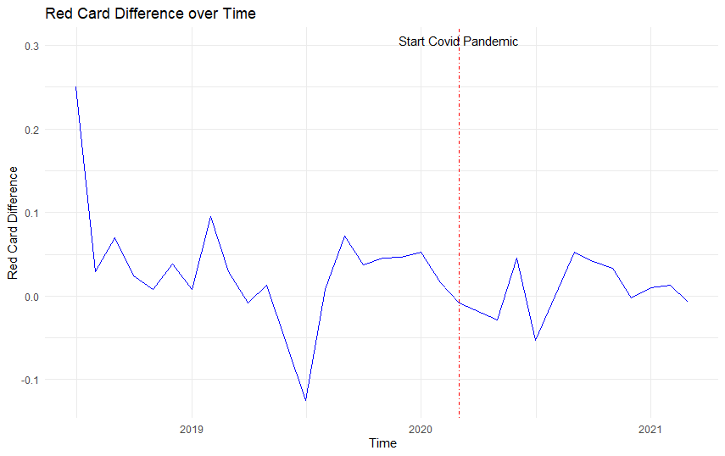

**Appendix 3b:**

This graph shows the evolution of the foul difference between home and away teams over the past 3 years. We see quite a substantial drop after the starts of the covid pandemic where the foul difference dipped into negative territory after having been positive for the majority of the 2 years before the Covid-19 pandemic.

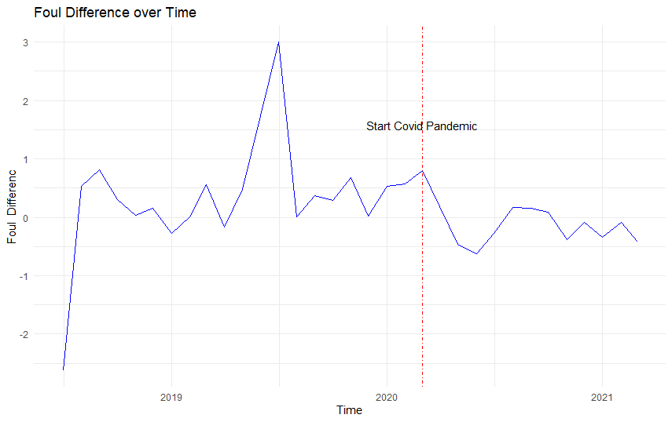

**Appendix 3c:**

Appendix 3c shows the goal difference over time. We see a very sharp reduction in the goal difference between home and away teams right after the start of the Covid-19 pandemic. However, afterwards the goal difference gap increases again but still remains a bit lower than before.

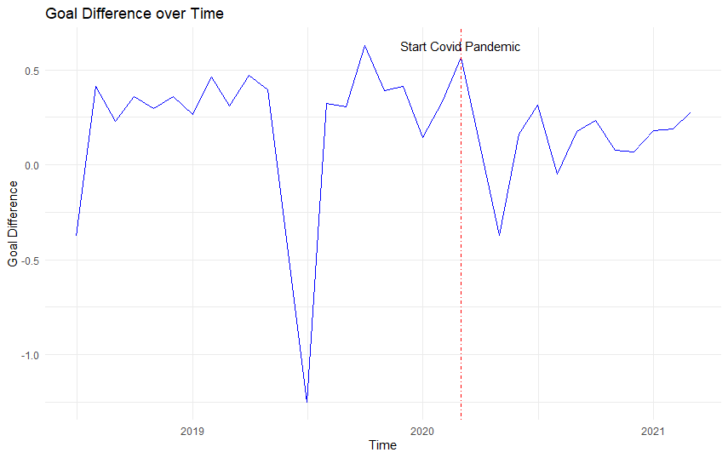

**Appendix 3d:**

Appendix 3d shows the points difference across the past 3 years. Similar to the previous graphs, we see a sharp drop right after the start of the Covid-19 pandemic. Subsequently, the difference in points tends to fluctuate quite much in the months after.

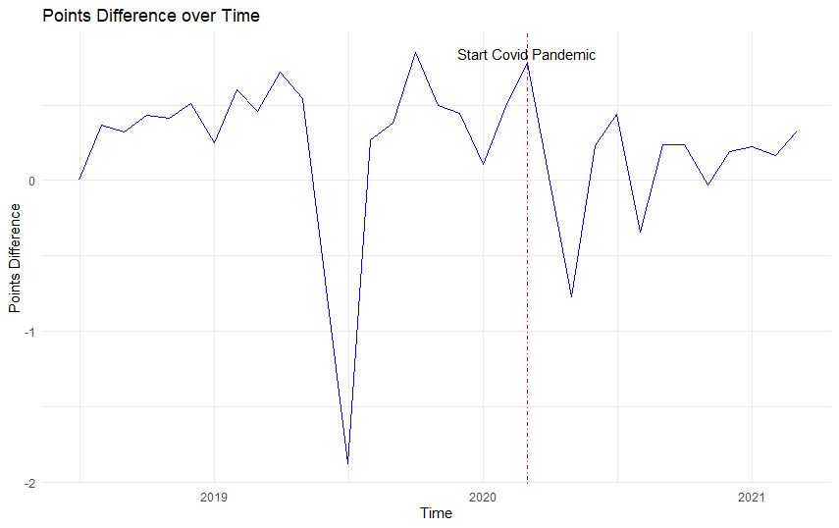

**Appendix 3e: Percentage points pre and post covid**

This graph shows that there is still a home advantage in the case of “ghost games”, since the error bars of the percentage of points for home and away teams do not touch in the right half. The gap between home and away teams however has significantly decreased.

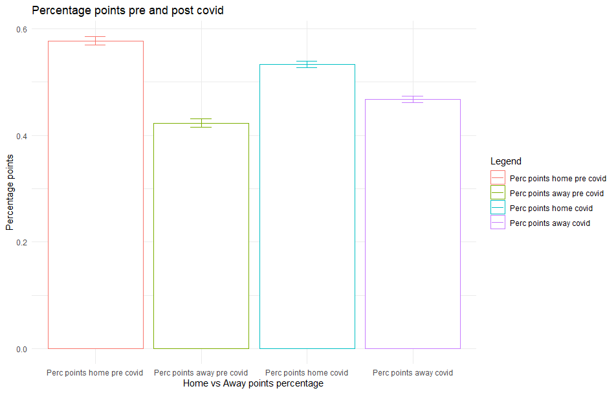

**Appendix 4a: Homoscedasticity indirect path**

Appendix 4a displays the plot for visual inspection of homoscedasticity. A straight red line indicates homoscedasticity, which in this case appears to be present.

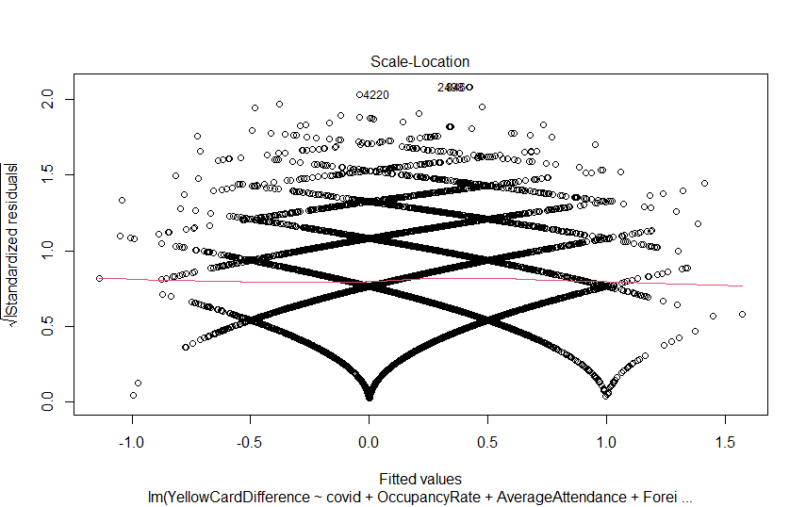

**Appendix 4b: Homoscedasticity direct path Goal difference**

Appendix 4a displays the plot for visual inspection of homoscedasticity. A straight red line indicates homoscedasticity, which in this case appears to be present.

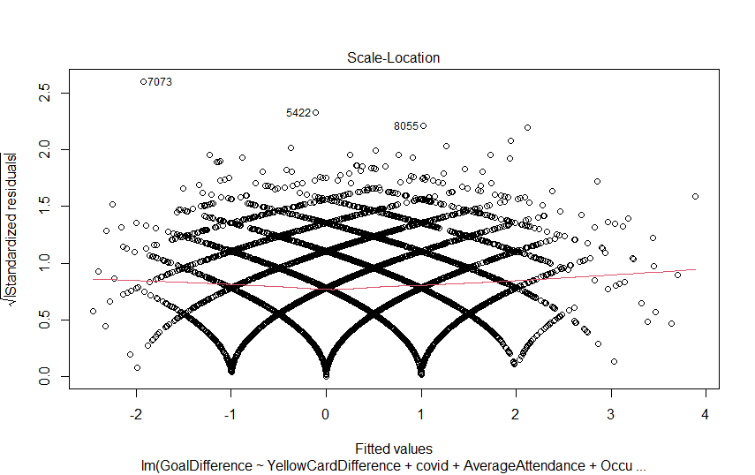

**Appendix 5:**

Appendix 5 contains the Non-constant Variance Scores for our model. Both tests cannot reject the Null hypothesis of Homoscedasticity.

Non-constant Variance Score Test Direct path

Variance formula: ~ fitted.values

Chisquare = 2.038949, Df = 1, p = 0.15332

Non-constant Variance Score Test

Variance formula: ~ fitted.values

Chisquare = 0.09479148, Df = 1, p = 0.75817

**Appendix 6**:**VIF table**

**A**ppendix 6 shows the VIF factors to test for multicollinearity. Since all our values are below 5 we deem multicollinearity to not be problematic.



**Appendix 7: Correlation table**

Appendix 7 shows the correlation table for the variables we include in our model. As expected a few variables correlate quite heavily.



**Appendix 8a**

Appendix 8a shows the results for our full model but with goal difference as dependent variable. The coefficients change slightly, such that the goals gap decreased by .202 following the exclusion of supporters compared to .285 for points. However, the significances and signs all remain the same. This indicates that our model findings are robust.



**Appendix 8b**

Appendix 8b shows the result for our robustness check with yellow cards as a measure rather than the latent construct of referee bias. Most coefficients do not change while a few show minor changes. Signs and significances remain the same, suggesting that our latent construct does not negatively affect our model.



A**ppendix 8c**

Appendix 8b shows the result for our robustness check with yellow cards as a measure rather than the latent construct of referee bias. Most coefficients do not change while a few show minor changes. Signs and significances remain the same, suggesting that our latent construct does not negatively affect our model.



**Appendix 8d**

We decided to remove red cards from our latent construct as it decreased the internal consistency. Red cards are given infrequently in matches and therefore have very small values with low variance. To check if our decision was right, we deploy our model with red cards included in the latent construct. The coefficients change slightly but the total effect for crowd support stays the same.



**Appendix 9a Goal Difference full model**

Appendix 9a shows the fit measures for our robustness check model with goal difference as dependent value. The fit values are very similar to those of our main model, only failing the cut-off value for the Tucker-Lewis index.



**Appendix 9b Point only yellow card**

Appendix 9b shows the fit measures for our robustness check model with yellow cards as observed value rather than a latent construct comprising yellow cards and fouls. The fit values are very similar to those of our main model, only failing the cut-off value for the Tucker-Lewis index.



**Appendix 9c Goal only yellow card**

Appendix 9c shows the fit measures for our robustness check model with yellow cards as observed value rather than a latent construct comprising yellow cards and fouls with goal differences rather than point differences The fit values are very similar to those of our main model, only failing the cut-off value for the Tucker-Lewis index.



**Appendix 9d point with red card**

Appendix 9d displays the fit measures for our robustness check model with red cards incorporated in the latent construct referee bias. Most of our model fit statistics decrease for this model, with especially the Tucker-Lewis index and comparative fit index showing lower model fit.



1. *Throughout this thesis, we will use this term to refer to referees’ decisions* 
2. *We use the term share of foreigners in this thesis. The variable is actually operationalized as the number of minutes played by foreign players as a percentage of total playing minutes for an entire squad*
3. <https://projects.fivethirtyeight.com/soccer-predictions/>
4. https://www.football-coefficient.eu/money/
5. https://www.skysports.com/football/news/11661/11358620/the-cost-of-relegation-what-is-the-financial-impact-of-dropping-out-of-the-premier-league